# Prompt Engineering for Web Developers

Sample prompt to generate a e2e app by Claude–

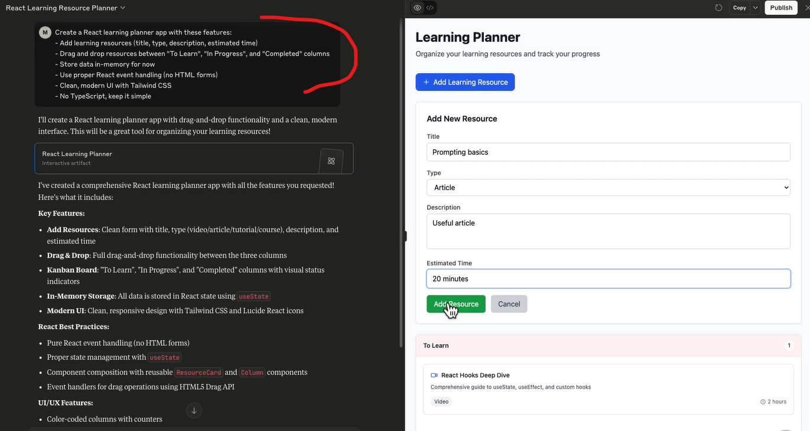

Vibe coding – using natural language to describe what you want to build, then letting AI generate the implementation. A fundamental shift in development, before we used to think of functions and classes first, we started with user experience and desired outcomes.

Prompting doesn’t replace coding, but good prompting amplifies our coding skills which is called prompt engineering.

Best practice for good prompt is to follow role-task-context-format framework –

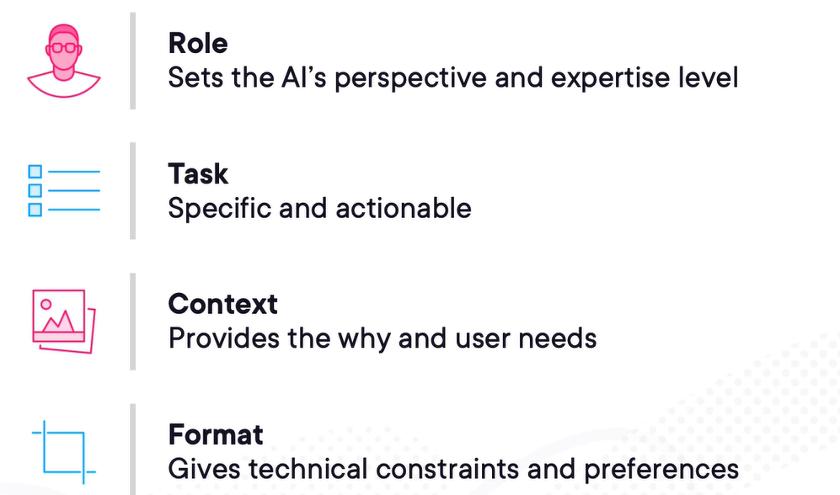

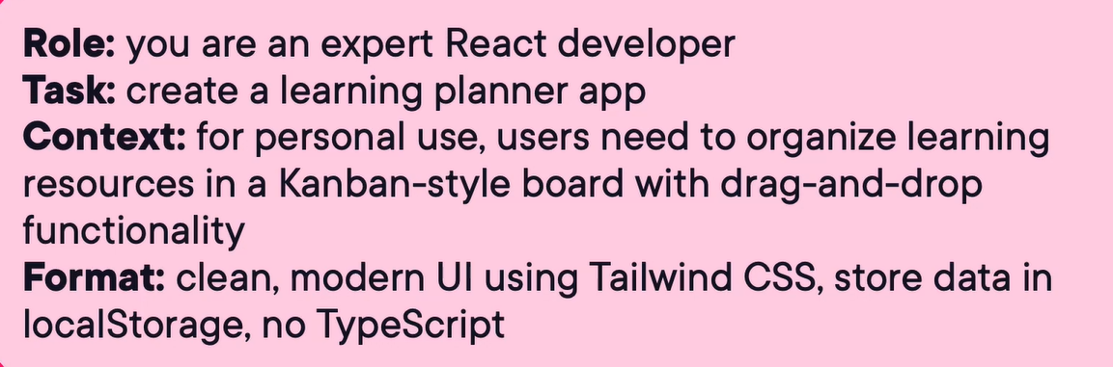

Typical problems with LLMs – Hallucinations – make up convincing but false information. Outdated training data, context window limitations.

Another example of good prompt for learning a new concept –

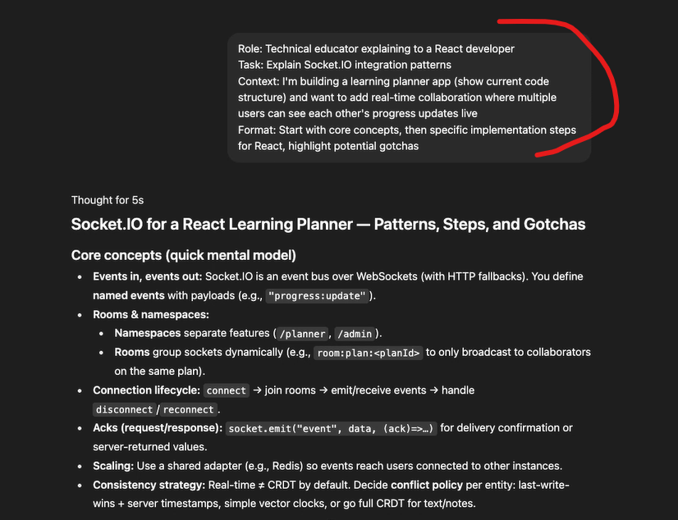

Good prompt example for comparison between different topics –

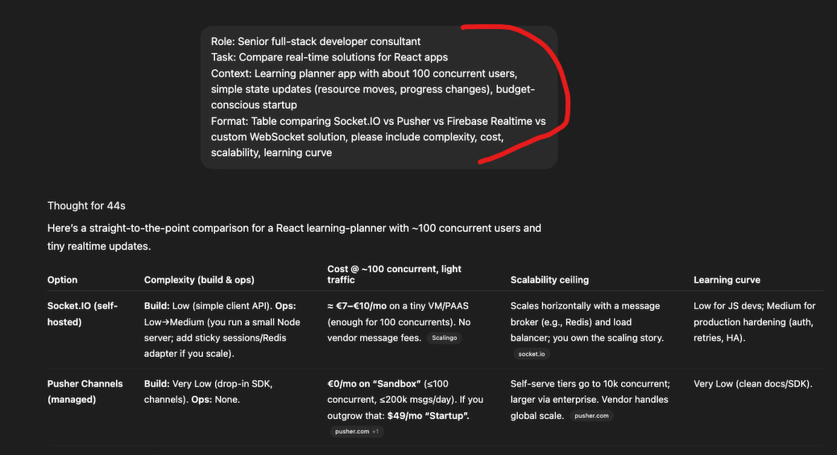

Good prompt example for creating user story for a new product feature. Then we can simply give this user story to git copilot to implement technically –

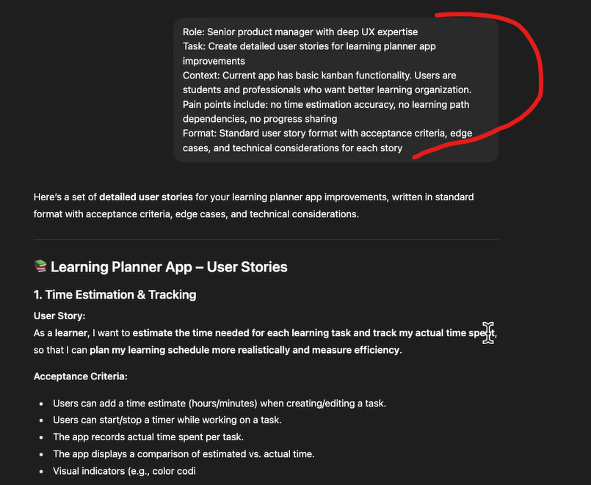

Good prompt example for writing e2e test cases –

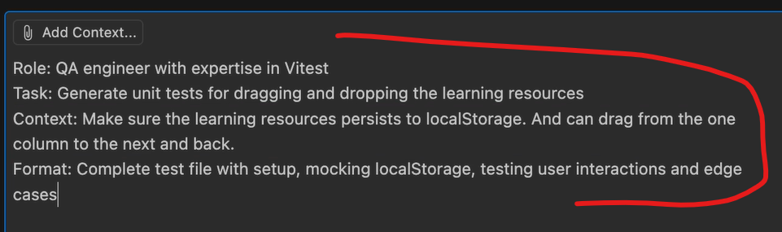

Another good use case of using AI is to general sample data by which our tests will make more sense when they are using realistic test data.

Another good sample prompts –

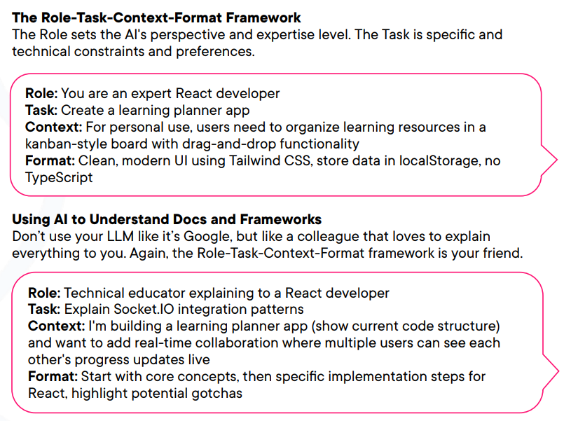

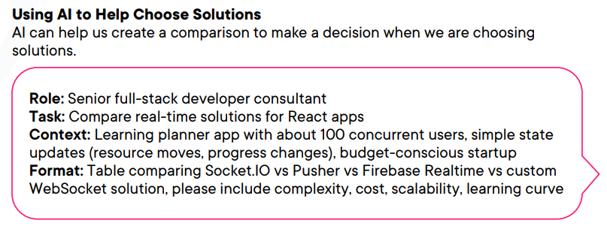

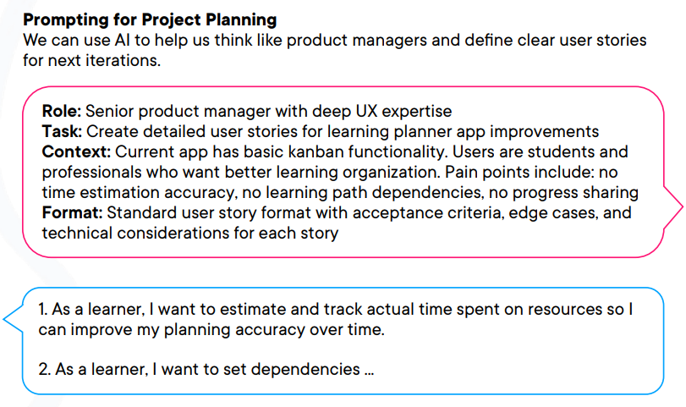

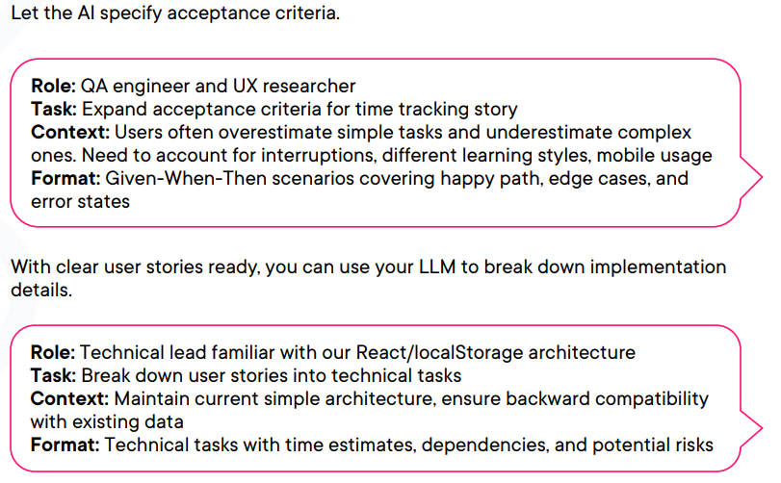

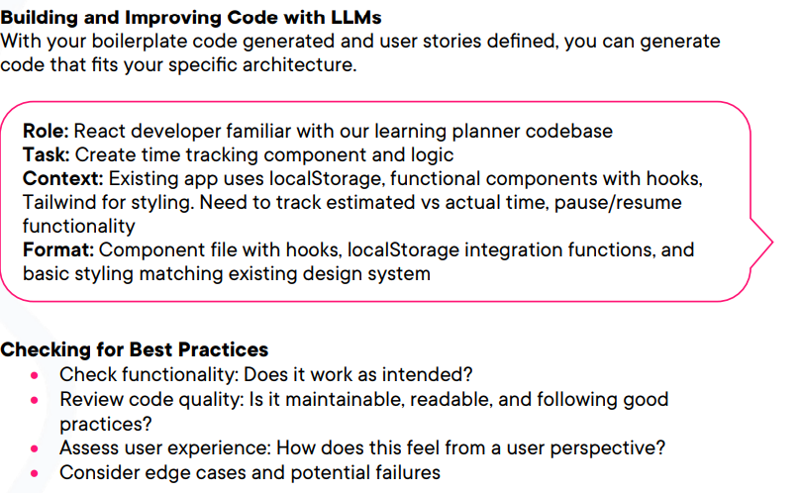

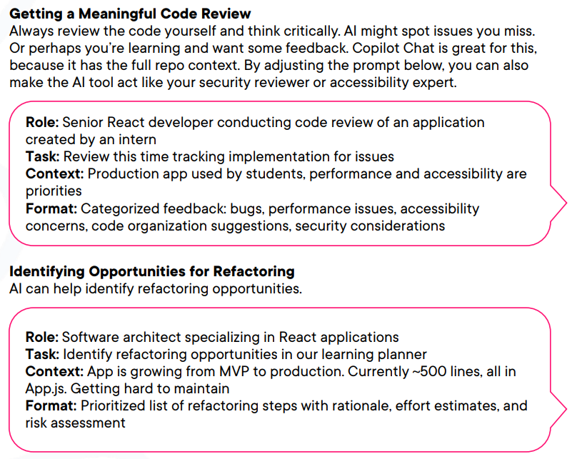

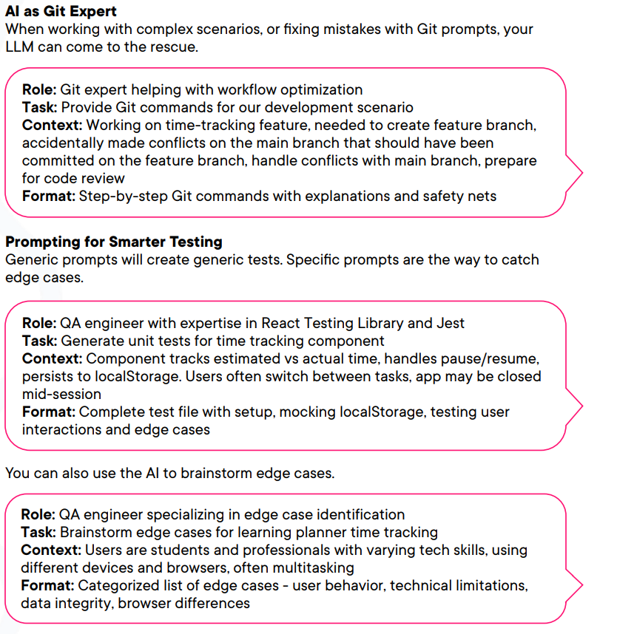

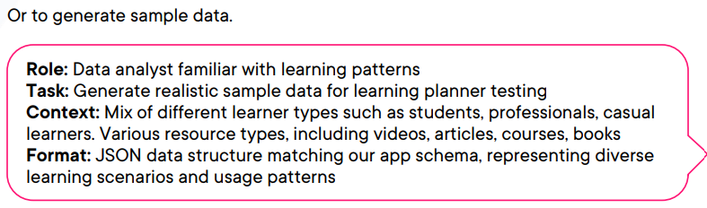

# Misc.

Best practices

Angular

When to Use Redirects vs Guards - Prefer RedirectTo (redirect function) Simple routing logic (e.g. “if not logged in, send to /login”, “if already logged in, skip login”). Prefer Guard - Complex checks, confirmation dialogs, unsaved changes, permission-based blocking

Containers

Why did containers happen? - Containers weren’t mainly about isolation in the VM sense, but about solving the problem of managing many applications, not just many machines. VMs (built for consolidating underutilized hardware) with containers (designed for packaging apps, making deployments reproducible and shareable). One “forbidden thing” Docker introduced was encouraging rebuilds and redeploys instead of patching in place. This shift supports immutability, which simplifies reasoning and (in theory) security.

# HTML

Best practices - The <output> element is intended to represent the result of a calculation or user action. Importantly, when the content (value) of an <output> changes, many screen readers automatically announce the update—without needing extra ARIA tweaks or manual announcements. Using <output> avoids moving focus, avoids interrupting the user’s flow, and reduces the need for extra JavaScript or ARIA workarounds. When you have UI that dynamically updates (e.g. calculators, live results, value changes), consider wrapping the result in an <output> element instead of a generic <div> or <span>. This small change can dramatically improve accessibility for screen reader users, with fewer hacks or extra scripting.

# UX Concepts: Design Systems

Most digital products are a patchwork of many decisions made over time, often by different people which causes inconsistency, redundancy and confusion for users.

To find out the issues on UI related to UX, a design audit is our first and most valuable step.

Component library – a component library is a collection of user interface elements, like buttons, cards, navigation, and more, that are the building blocks of a design system. It brings consistency, scalability and efficiency. Real examples -

<https://polaris-react.shopify.com/>

<https://m3.material.io/>

Organizing components – atoms, molecules, organisms and templates.

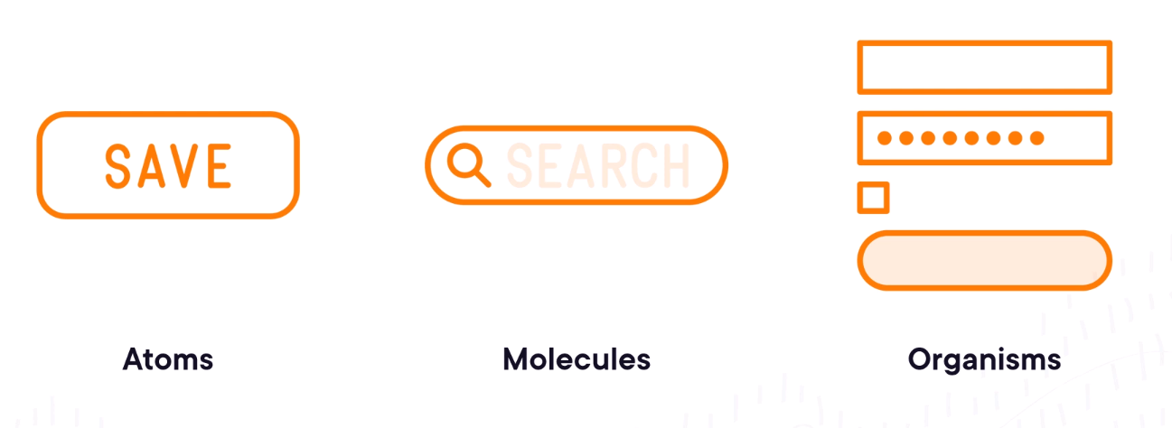

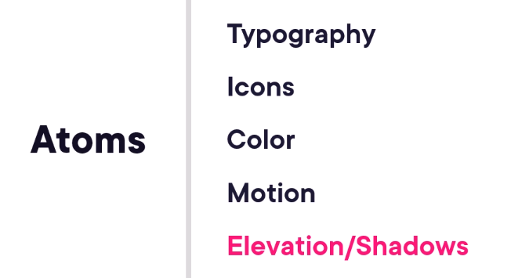



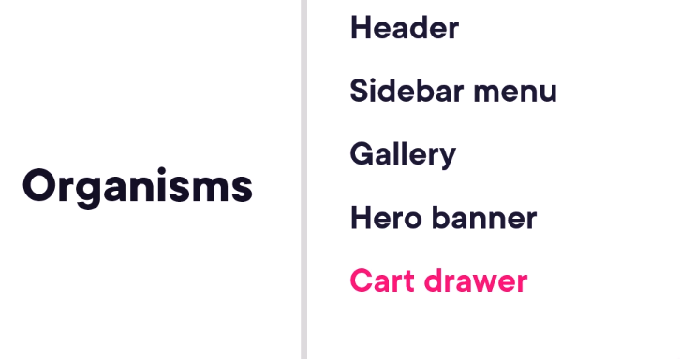

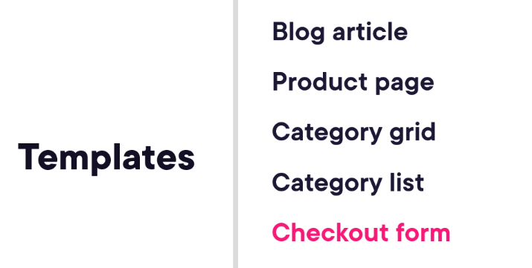

Components are the “What”, designs tokens are the “how”, naming conventions ensure the two systems align, making our design system scalable and unambiguous.

By creating a grouping of sizing references for tokenization, this enables a single source of truth just for sizing tokens, and it makes naming conventions a little easier to scan and manage over time.

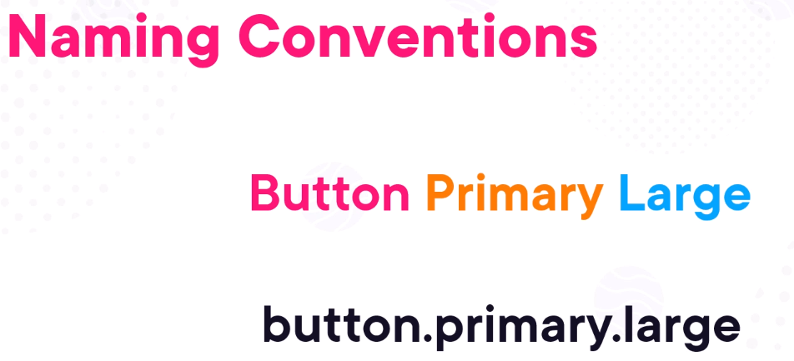



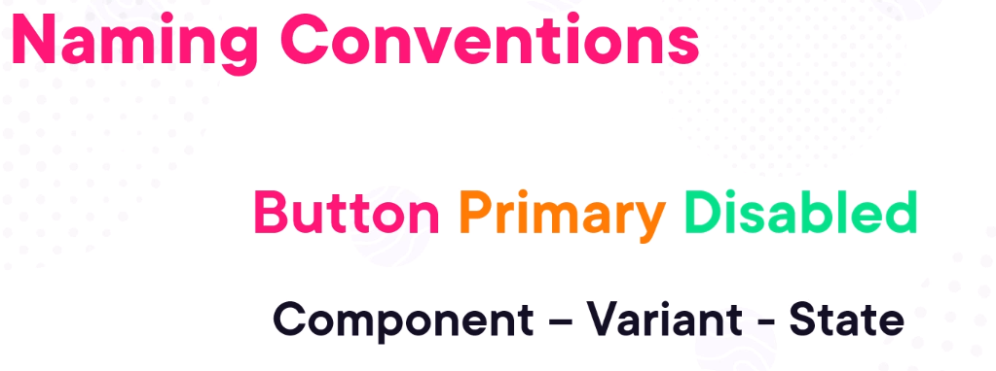

Design tokens is a method to express design decisions, platform-agnostic, shareable across disciplines, composed from a common vocabulary.

Tokens get codified in terms of JSON –

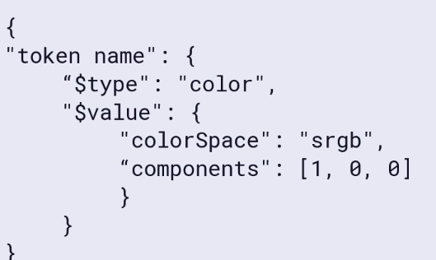

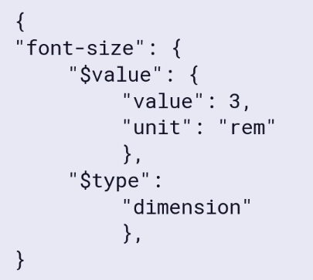

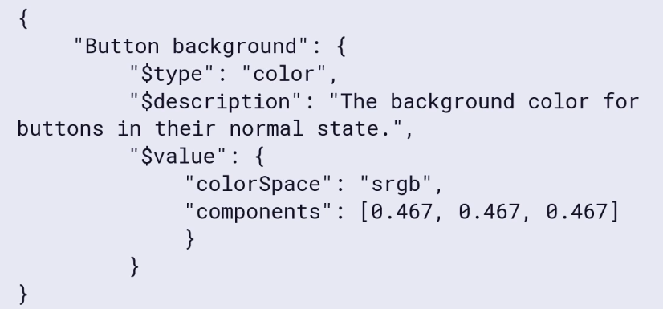

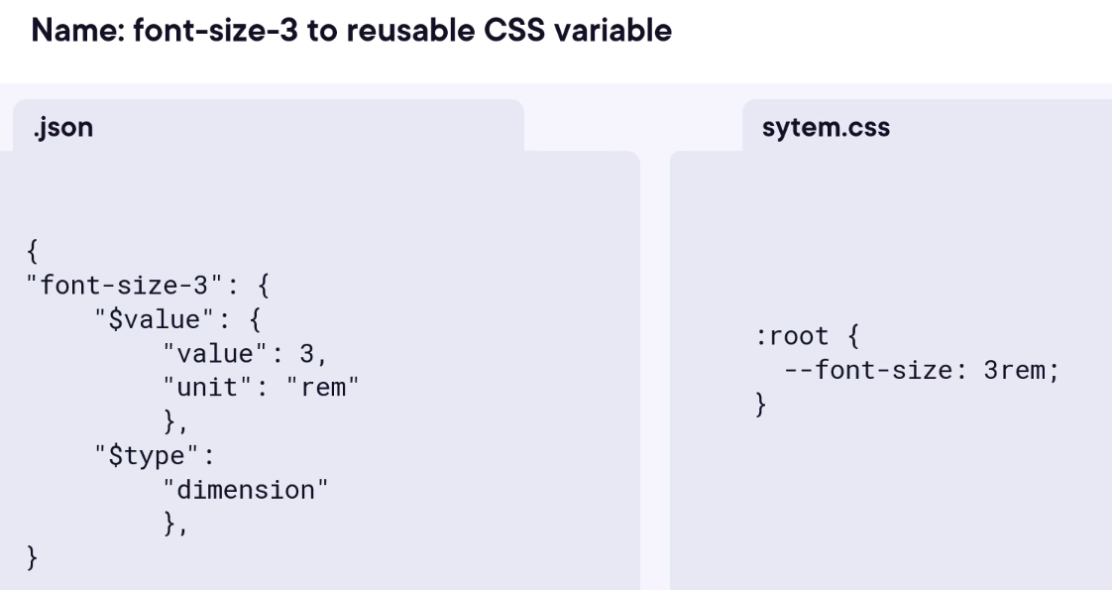

A design tokens can be easily translated to *.json, *.js and *.css files –

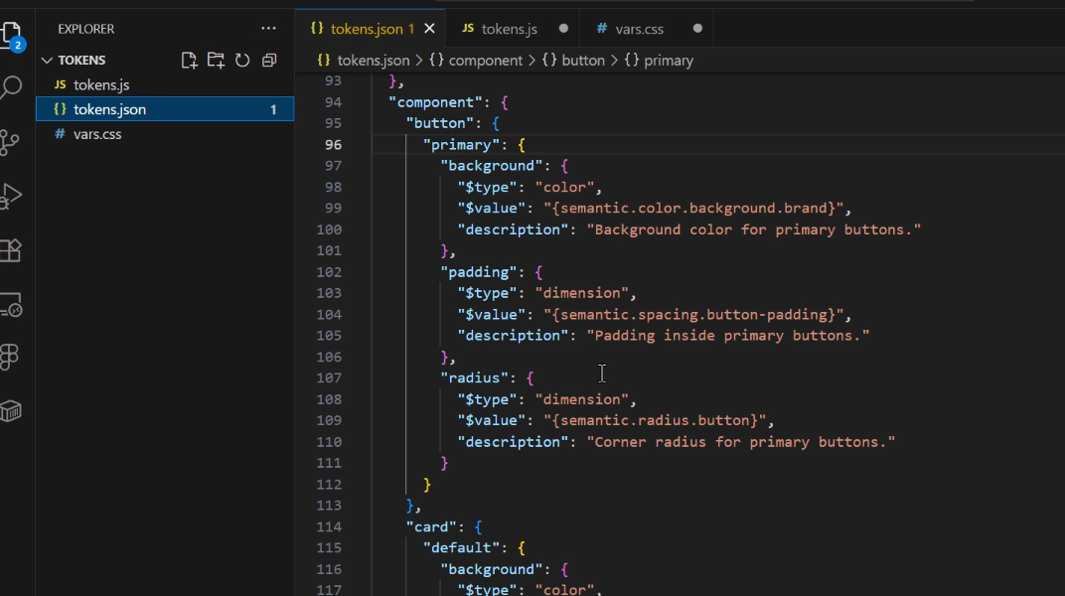

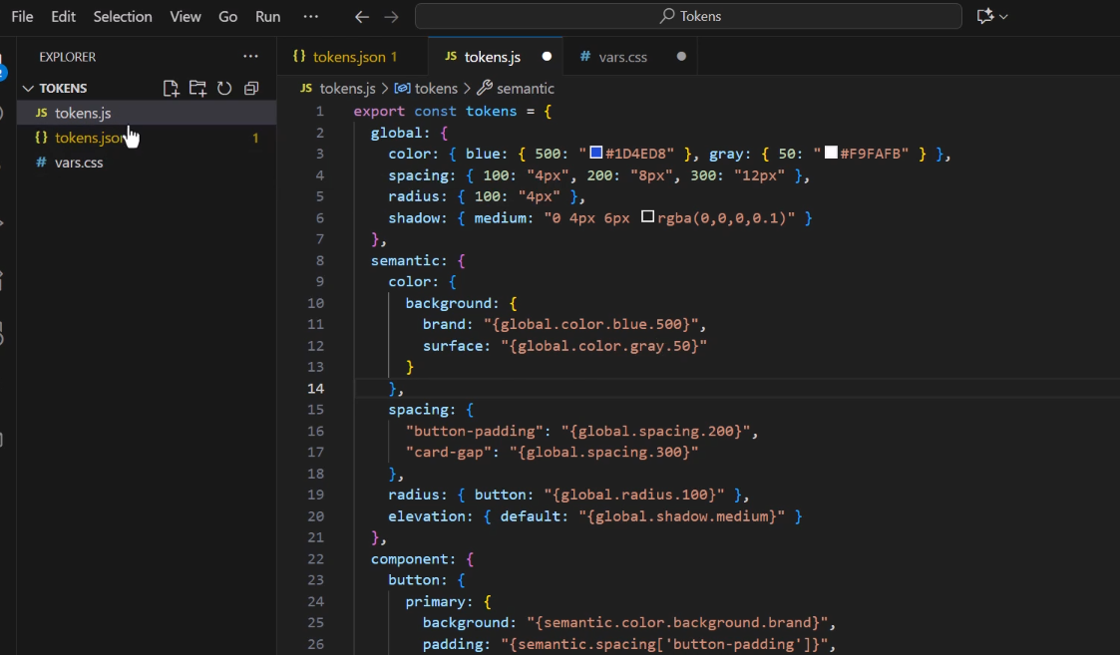

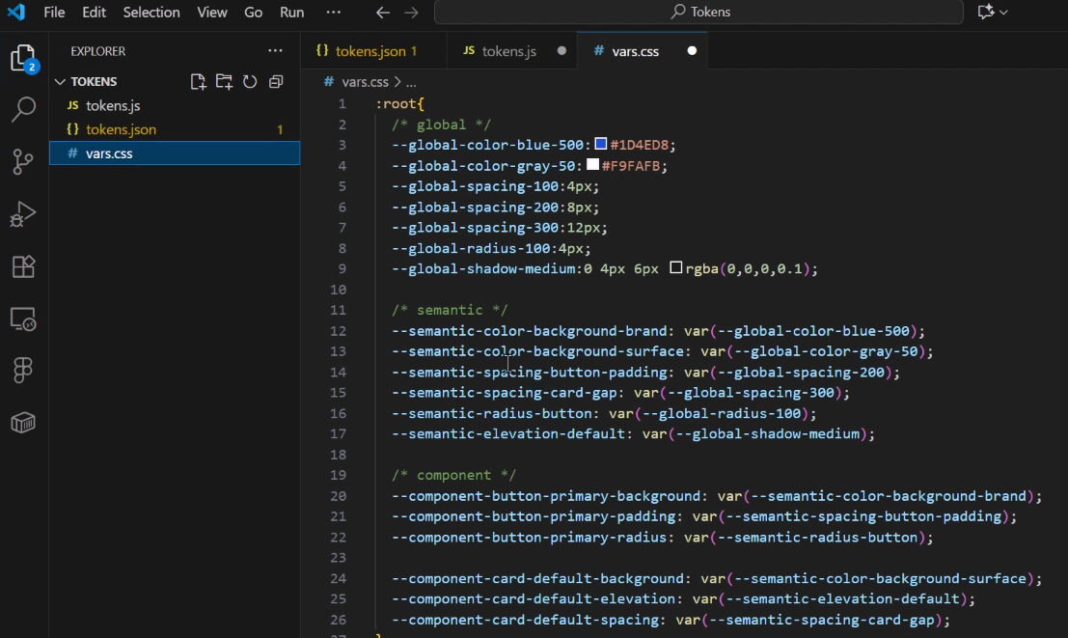

# UX Best Practice

Don’t block the flow - Keep the main action button (e.g., submit or continue) enabled to allow users to proceed. If there are issues, display clear error messages after submission.

Disabling the button preemptively creates confusion - users won’t know which validation criteria are missing, which increases frustration and cognitive load.

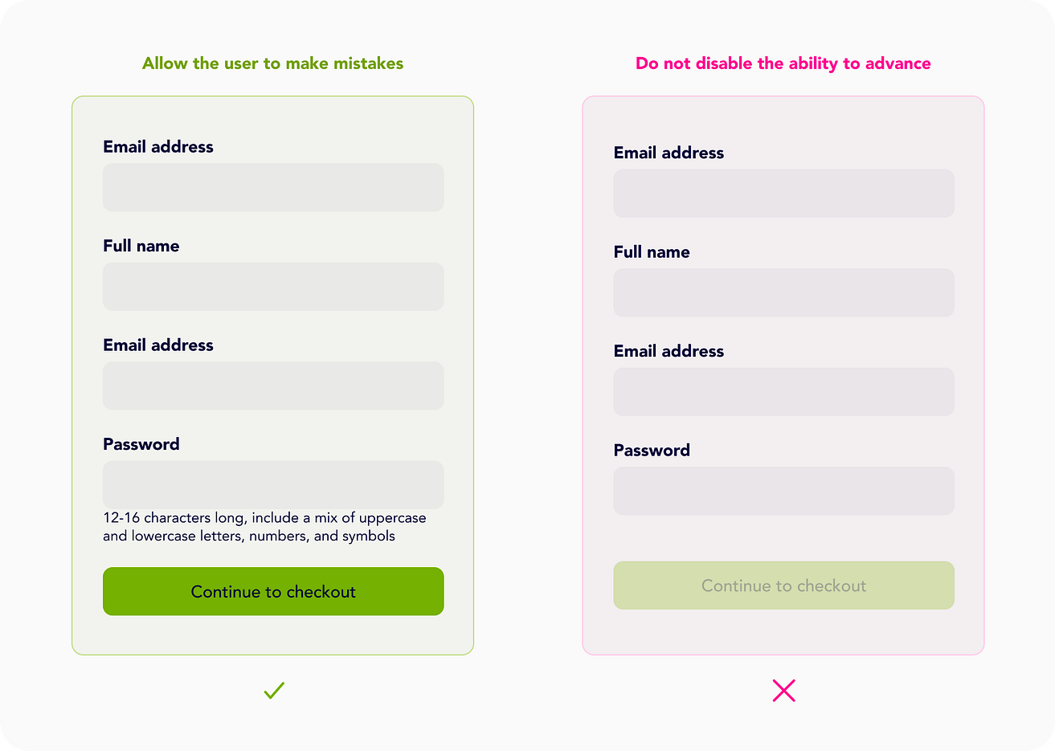

# React: The Big Picture

History of React - It was created by Facebook to use in Facebook then in Instagram. In 2015 Facebook also made React Native open source which is used to create mobile applications for iOS and Android using React. Facebook used React to slowly replace its server-side rendered PHP application. They started with small portion of the existing page the move on to slightly larger portion on the page, and eventually rebuild the entire page, it is low risk migration approach.

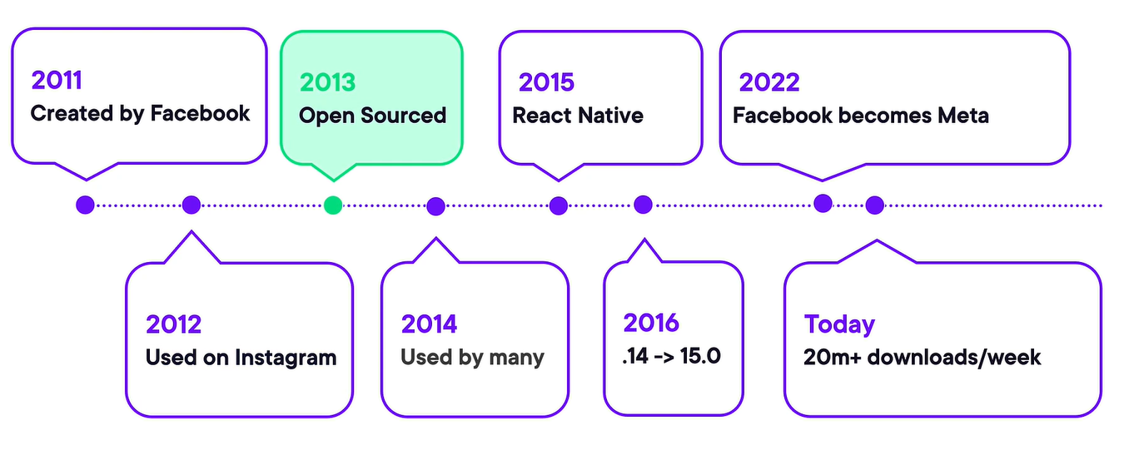

React embeds fewer opinions than its competition like angular or Ember, so it is more flexible than opinionated frameworks. React is a library not a framework. Initially it was created for creating web components but its ecosystem has been grown like for static sites we can use Gatsby and Phenomic. Using Next.js we can do server-side rendering.

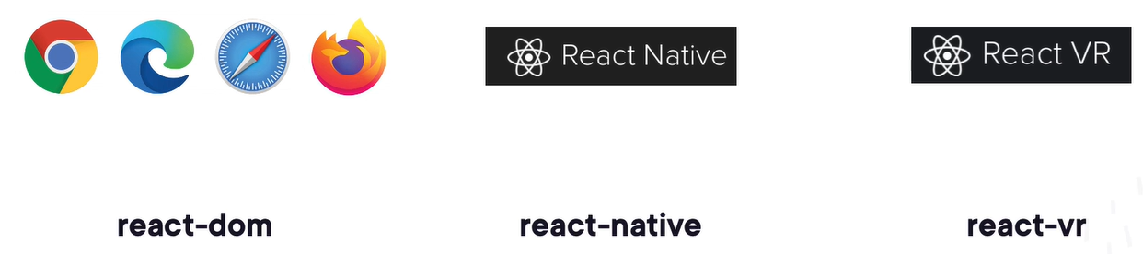

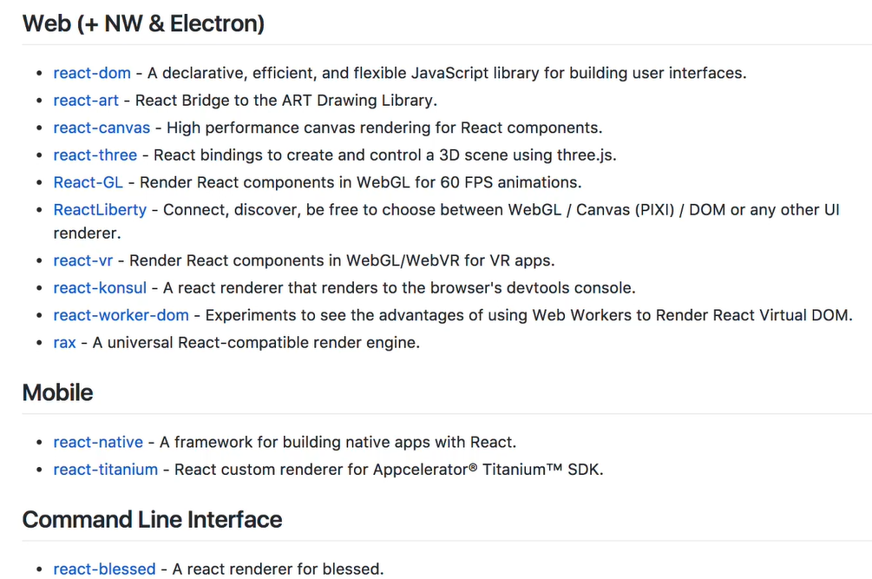

Hello world in react – JSX looks like HTML, it complies down to JS.

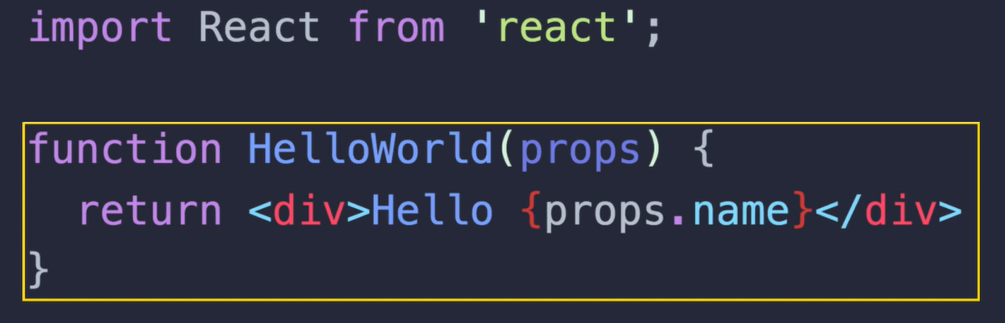

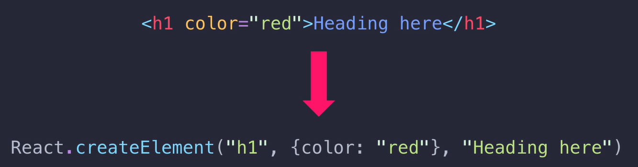

Unlike other framework, instead of trying to make HTML more powerful, React just handles HTML with JS. Traditional libraries put fake JS in HTML, React is doing the exact opposite, it puts fake HTML in JS, which creates simpler API.

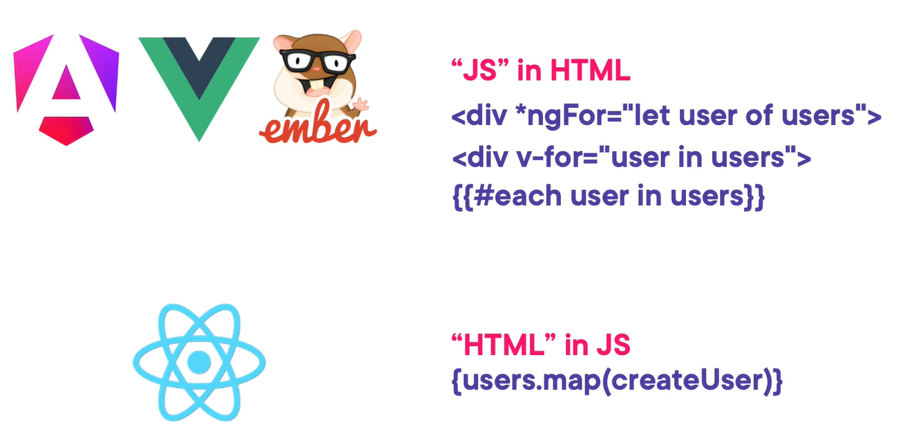

CLI commands –

“npm create vite@latest”

With React codemod, we can automatically update older React components to the latest application.

Companies using React –



Material component UI for react –

<http://mui.com/>

Ecosystem –

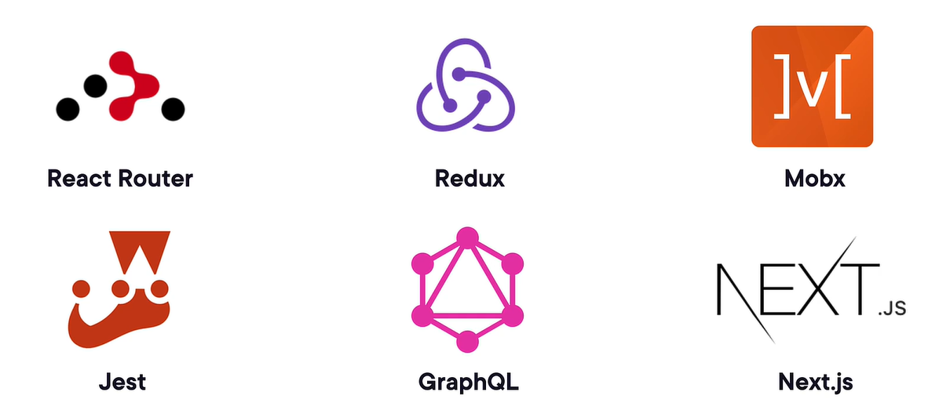

Why react is fast – memorize, specify low-priority updates, lazy load, can server-render, can generate as static HTML, powerful dev tools.

Inferno and Preact both library have similar API like React but have much lesser package built size.

Tradeoffs in React –

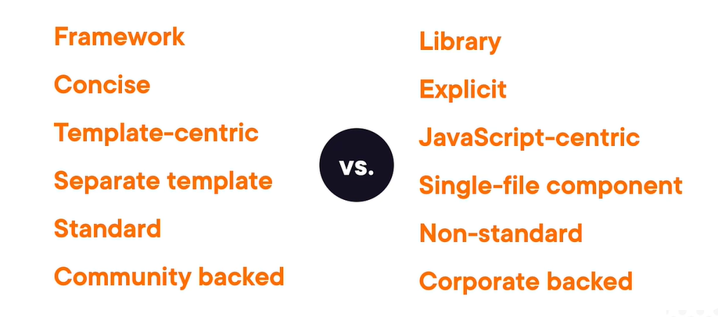

We have to choose what we need –

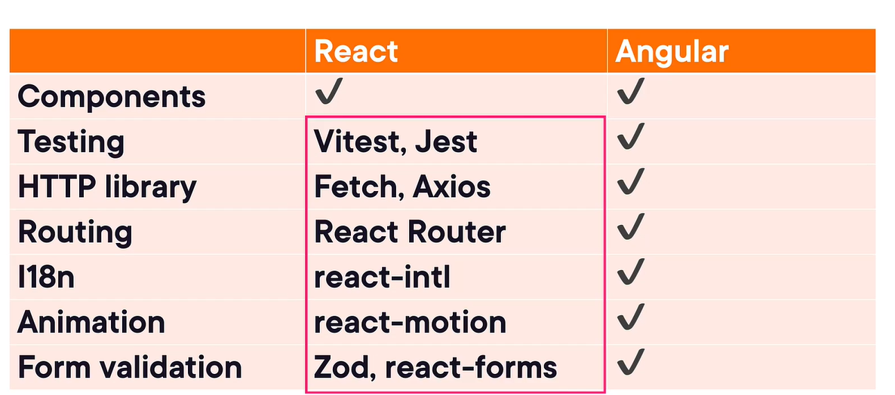

React uses one way binding which need more code but it gives more control, more explicit and easy to debug. –

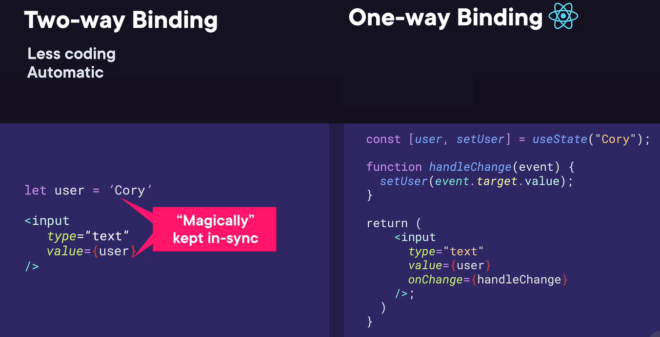

Instead of template-centric it is JS-centric –

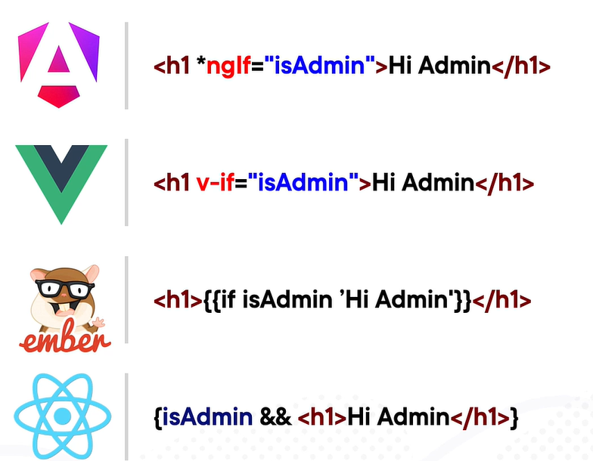

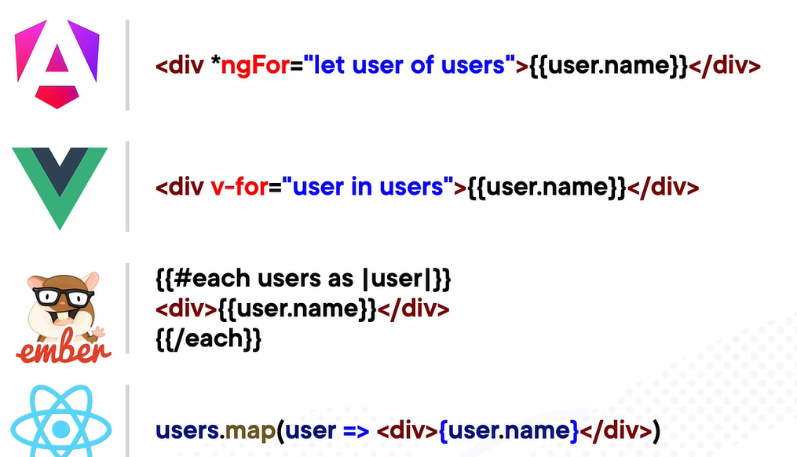

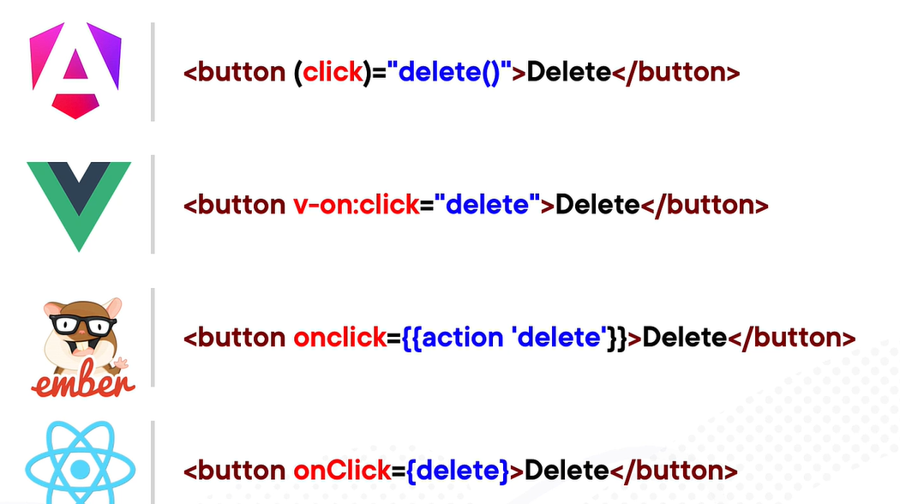

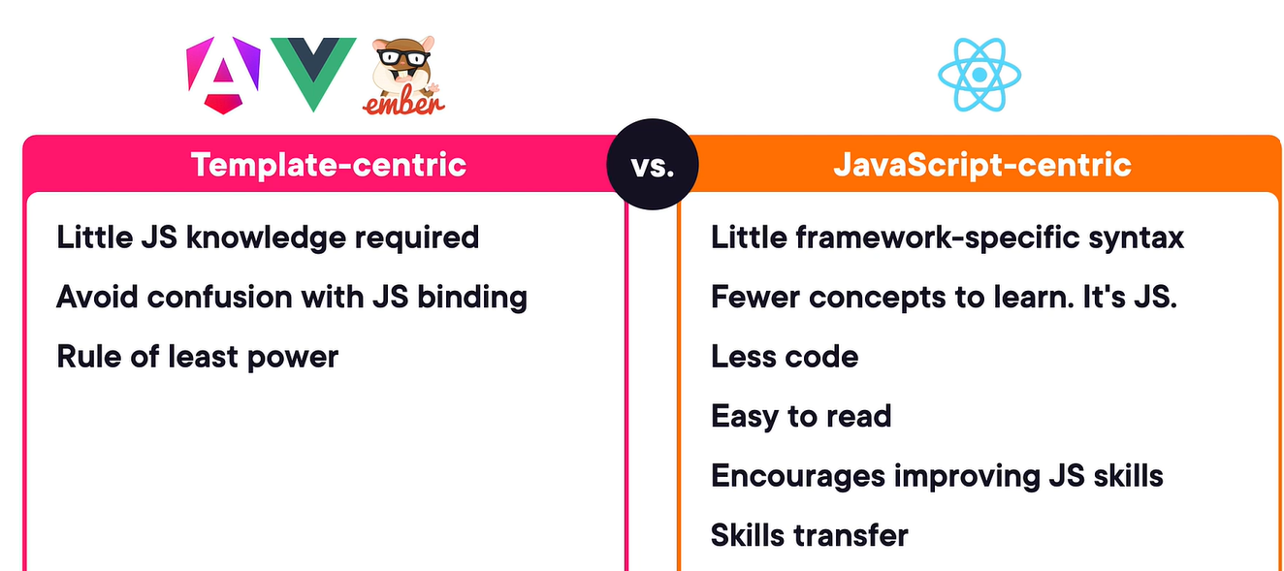

Separate vs. single file – instead of separating the technologies into separate files, it considers each component is a separate concern. Putting technology into separate file can actually hider debugging and slows feedback –

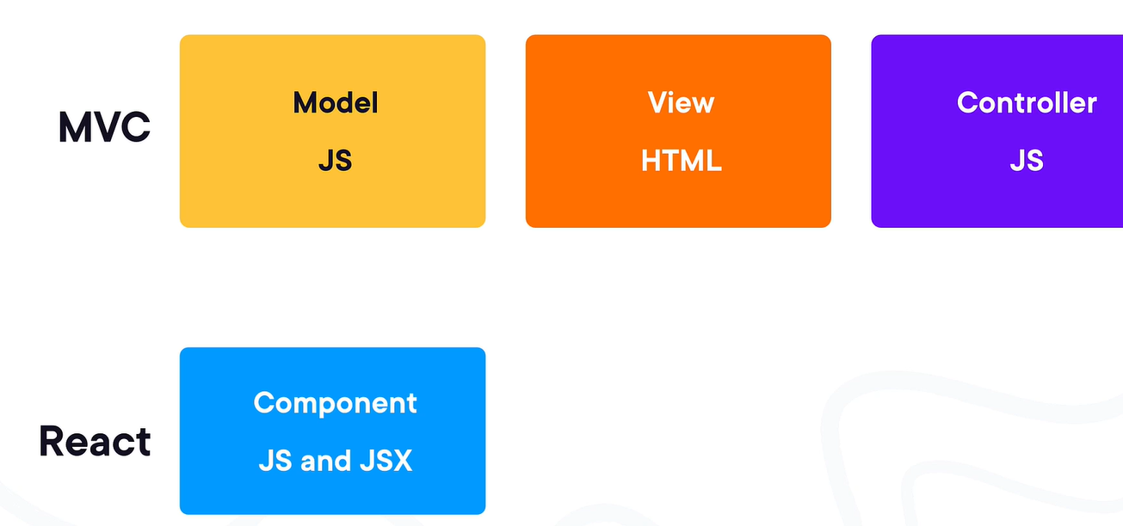

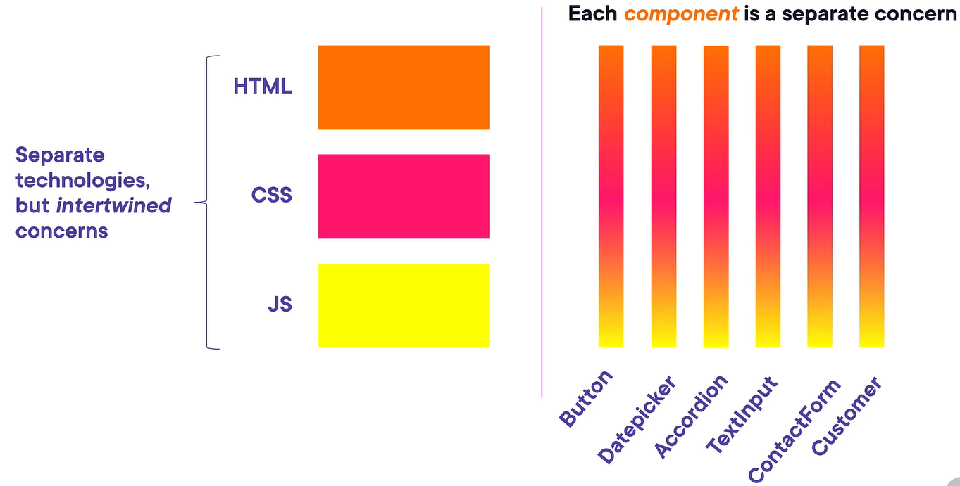

With component approach we can design pages into smaller components like Russian dolls –

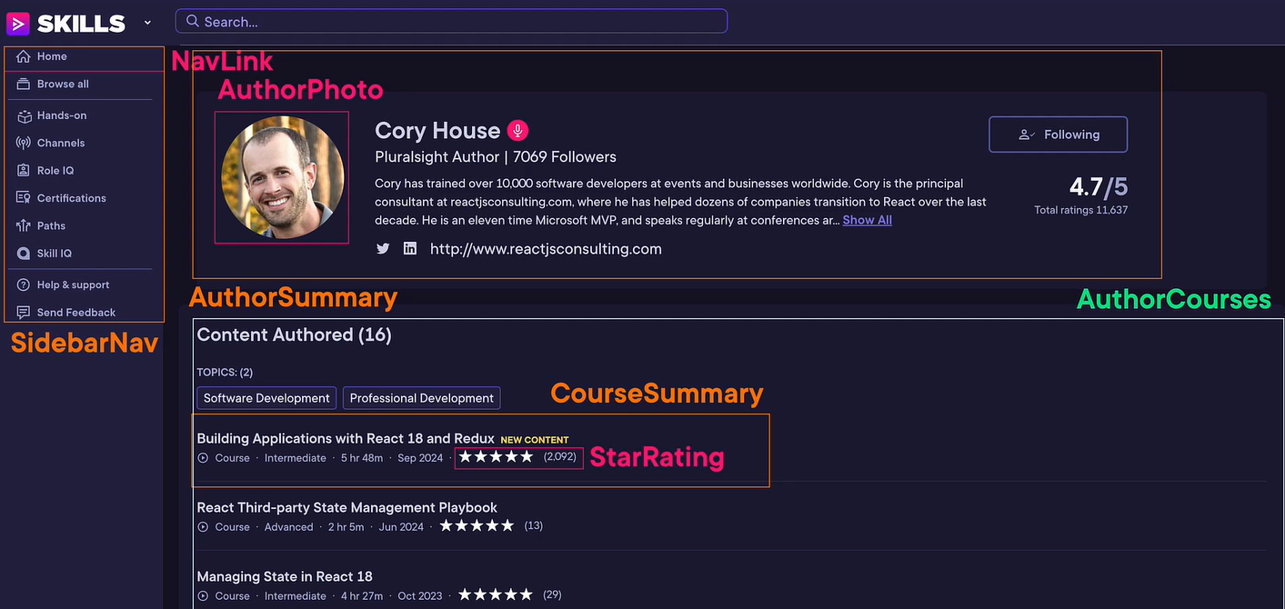



Standard vs. non-standard – Instead of building web components using standard technologies which provides templates, custom elements and shadow DOM feature, we still use frameworks like React or angular to built them in a non-standard way. JS libraries have nicer APIs and keep innovating, it is unlikely for standards bodies to keep up with JS innovation.

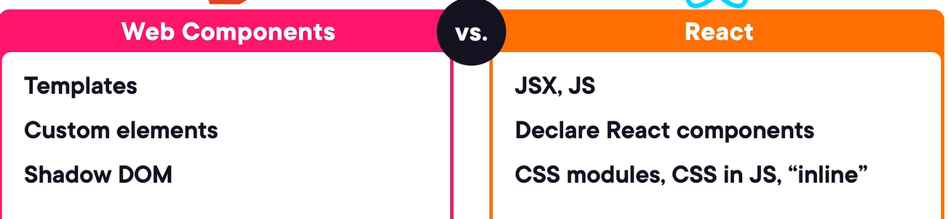

Why not React – JSX differs from HTML, build step, potential version conflicts, old features in searches, decision fatigue.

React uses an optional syntax that looks a lot like HTML called JSX, it is 99% similar to HTML but sometimes differs like –

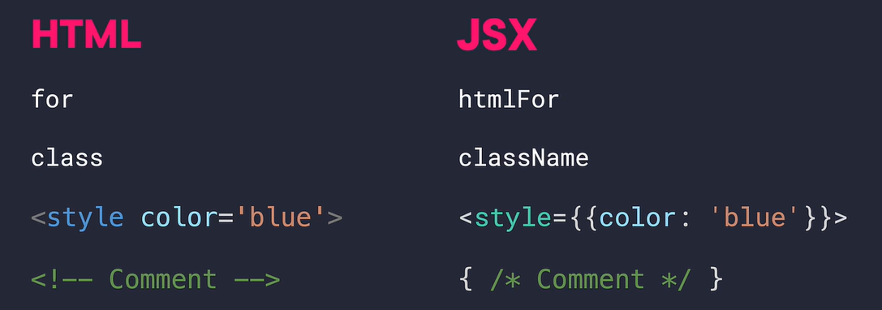

In standard web components API, there is no run time so need to worry about version conflicts but react have runtime due to which it can cause potential version conflicts.

Features extracted from React core –

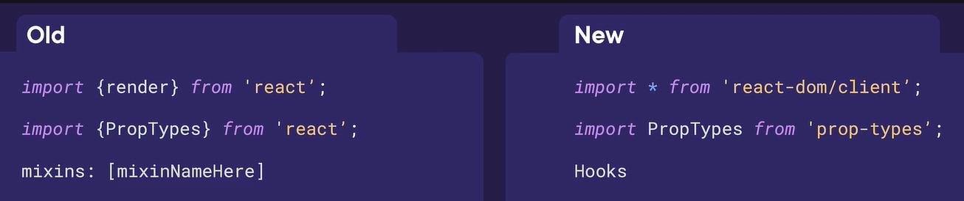

Decision Fatigue – five major decision to take before create app in react – dev environment (use Vite), classes or functions (prefer functions), handling types (prefer typescript), state (react itself handle state in great way, start with plain react then maybe use Tanstack or redux library) and styling.

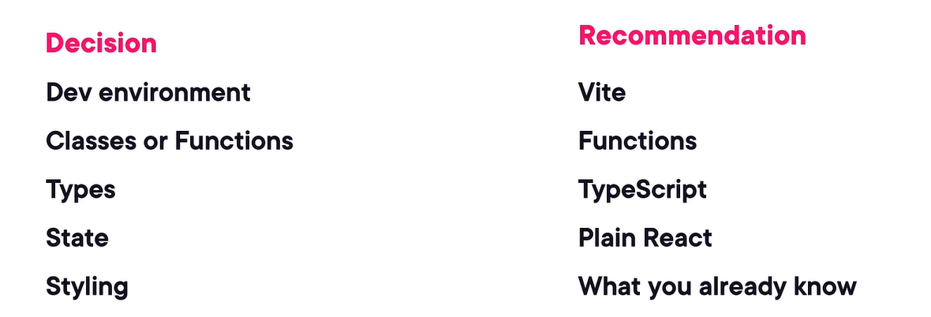

# Angular – Misc.

Visual representation of clean architecture layers in an Angular feature module. See how the Presentation, Application, Infrastructure, and Core layers interact with components like ProductList and ProductStore.

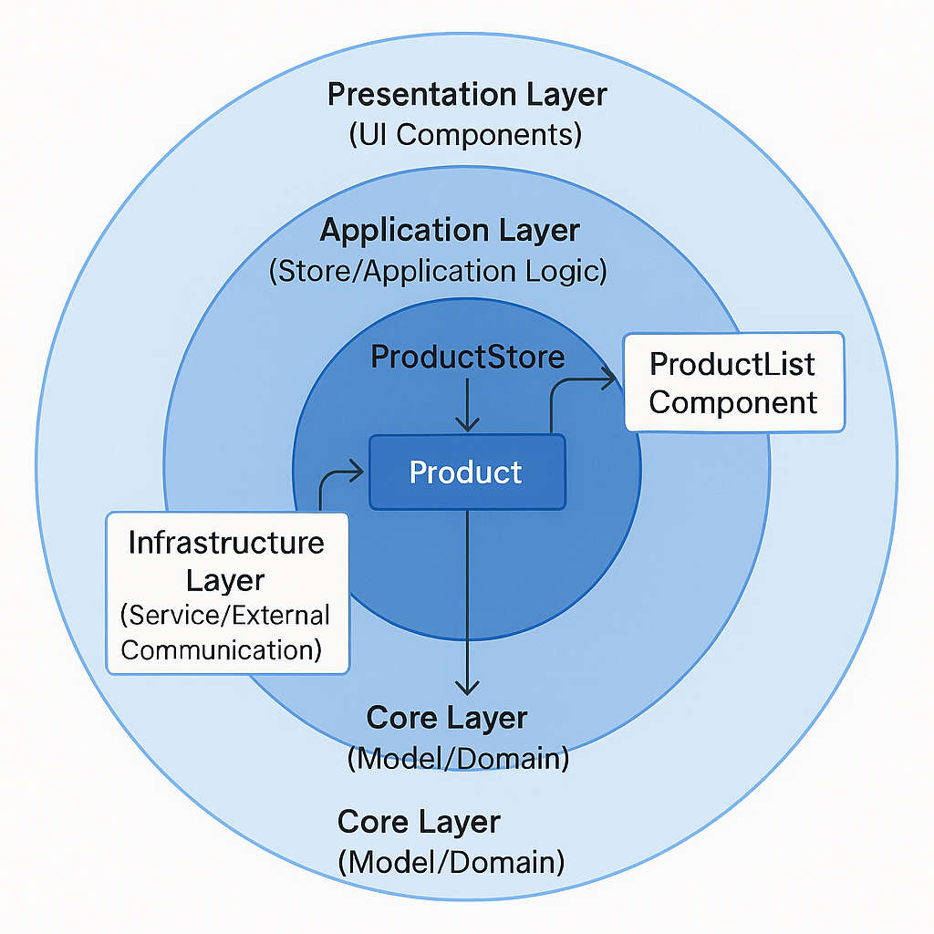

# UX – Misc.

Users View Details Better with Slideovers

The conventional approach to displaying details is no longer the best option. When users click to view details, you typically display them in a full-page layout. But did you know this full-page layout can slow users down and make information hard to find?

Most designers aren’t aware of this because they’ve followed the same practice forever. However, if you want to help users find information faster, you should opt for a more compact layout to display details.

Viewing details in a compact layout reduces scanning time because of smaller saccades. Users don’t need to move their eyes across the page in broad movements to gather information. A more compact layout brings the data closer together, so the eyes don’t have to do as much work.

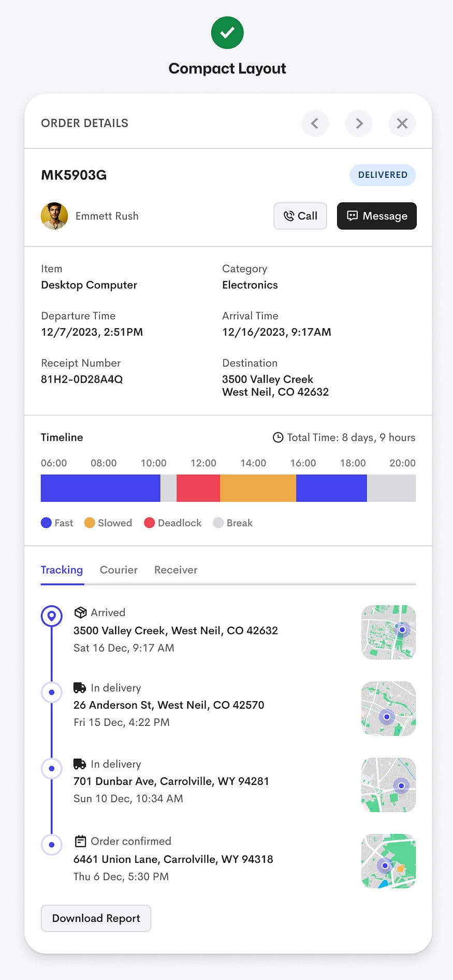

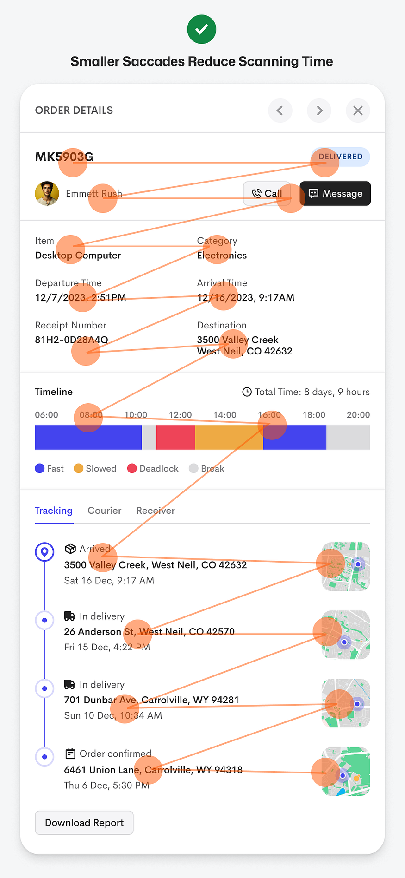

**When to Use This Pattern**

* When users need to glance quickly at details without losing their place in a list or summary.
* When you want to provide more details but not fully disrupt the flow of browsing.
* In contexts where maintaining the user’s orientation is important (e.g., inside a data-table, list of cases, etc.).
* But be mindful: A slideover might not work if the details are extremely complex or require a full view; sometimes a full page is still valid.

**Considerations / When Not to Use**

* If the detail content is **very long or dense**, a slideover might constrain readability.
* If the user needs **full screen real estate** (e.g., large charts, many fields) then full-page might be better.
* Need to ensure good performance, accessibility, and clear affordances (closing the slideover, navigation back) so the pattern doesn't confuse users.

>best practices - Understand cards vs panels and use semantic HTML. Cards for actions, panels for structure, and always pick the right HTML elements to improve accessibility and maintainability.

>While building, focus on: Component structure and proper separation of concerns, State management (local state, lifting state up, maybe context), Data fetching / asynchronous flows if needed, UI-logic separation and good patterns of design, Handling edge cases and building something you would feel okay showing to others

>The Angular CLI now includes an experimental Model Context Protocol (MCP) server. MCP is a standard interface that lets AI tools (in your IDE) interact with local development tools (like CLI) in a structured way. In this case: the CLI exposes project context, scaffolding, documentation, etc, so your AI assistant (or tooling) can “understand” your Angular workspace, instead of just generic code.

>do less “churning code” and more thinking, designing, mentoring, system-level decisions. That work requires energy and clarity — which overwork undermines.

>AI can code, but it can't build software. Coding is easy, software engineering is hard. Building a production-ready app is not coding, it’s software engineering.

>send snapshots for putting that page into stepper

the next wave of front-end innovation lies: beyond “responsive design” or “single-page apps” — into interfaces that understand context and adapt themselves.

The “generative UI” idea could influence your low-code UI framework: imagine letting an AI generate new screen configurations (JSON) based on user intent or prompt.

Integrate with your JSON-config form renderer so it can automatically pre-populate or revise fields.

Outcome:

→ Demo screen where typing “Apply for a 25-year mortgage of £350k in London” auto-fills loan type, tenure, and city fields.

1. “AI-Driven Form Completion”

Concept from article: Structured completions — AI fills form fields intelligently instead of users typing every detail.

Experiment:

In Angular, create a directive like aiSuggest="loanApplication" that connects a text prompt or uploaded document to your backend.

Spring Boot backend exposes a /suggest-fields API that takes user prompt + context and returns JSON field values.

Integrate with your JSON-config form renderer so it can automatically pre-populate or revise fields.

Outcome:

→ Demo screen where typing “Apply for a 25-year mortgage of £350k in London” auto-fills loan type, tenure, and city fields.

2. “Generative UI from Prompts”

Concept from article: Generative UI — the AI knows your component library and assembles screens dynamically.

Experiment:

Define metadata for all available UI components (textField, dropdown, chart, etc.).

Add an Angular service UiGeneratorService that accepts a natural-language prompt and produces a JSON UI config (e.g. via OpenAI API or Bedrock).

Render that config using your low-code engine.

Outcome:

→ User types “Create a dashboard showing total loans by month and average approval time”, and your app builds it live.

🧪 5. “Explain This Screen” Mode

Concept from article: Transparency & comprehension — users understand what’s on screen.

Experiment:

Add a “?” icon on each Angular page; clicking it calls /ai/explain with the current screen’s JSON config.

Spring Boot backend uses an LLM to summarise purpose, data sources, and key actions.

Outcome:

→ Users (or onboarding testers) can get natural-language explanations like “This page shows active mortgage cases and lets you upload supporting documents.”

# UX Misc

Users Complete Forms Faster with Floating Labels – With top-aligned labels, every field requires two fixations: one to the label, one to the input. This doubles the work the user’s eyes must do for each field. With floating labels, the eye uses a single fixation for both the label and the input, reducing friction and enabling a smoother scan.

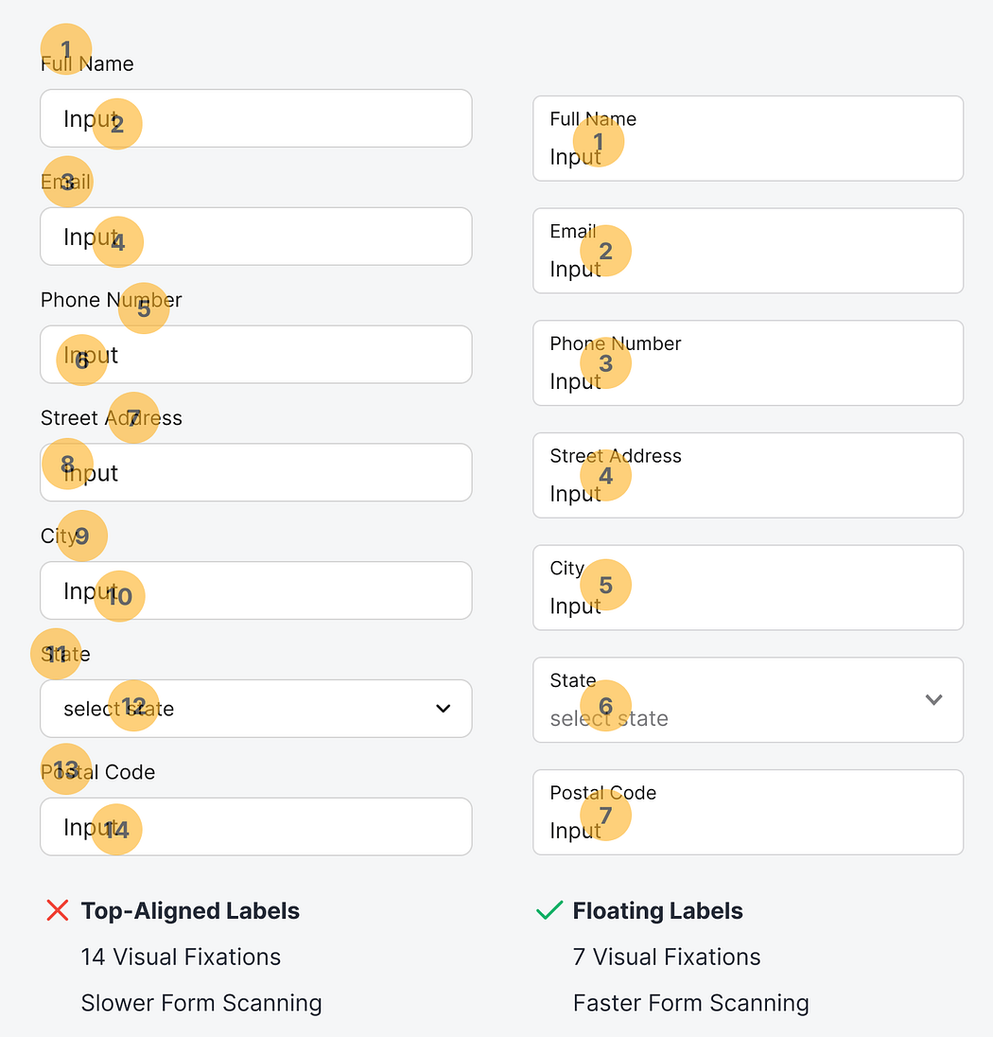

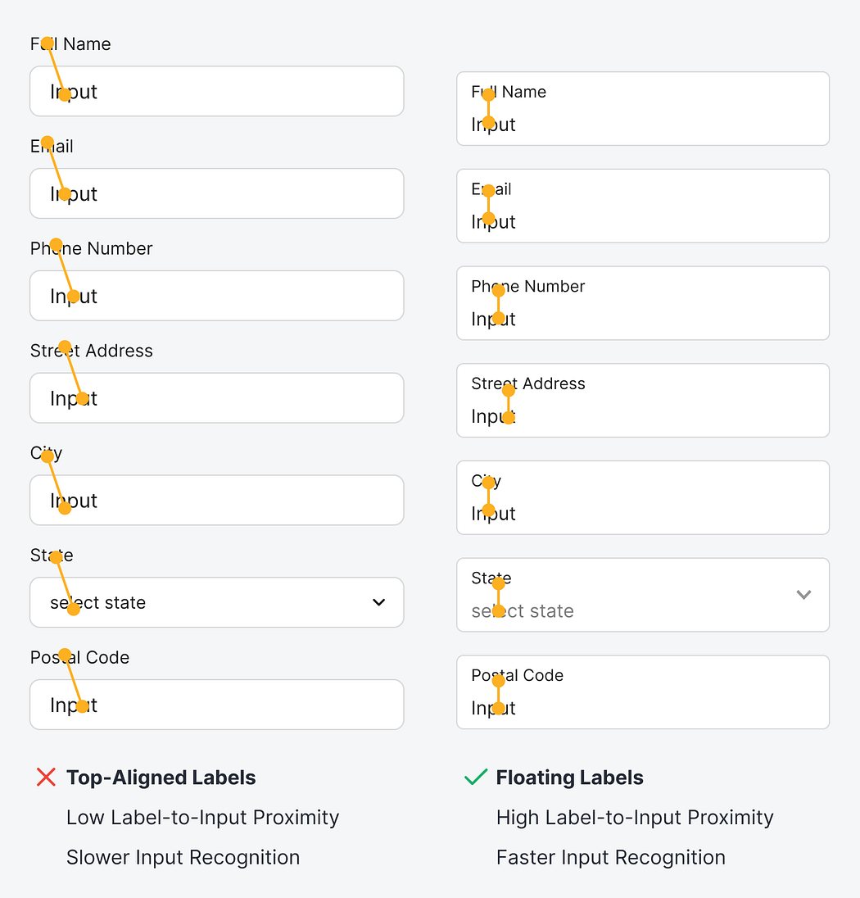

# Integrating Tailwind CSS with React

Command – “npx tailwindcss init -p”

Instead of including the rules for every possible utility class which would result in a huge file, tailwind’s analyzing ay of those files that show up in the paths specified in the Tailwind config for Tailwind classes.

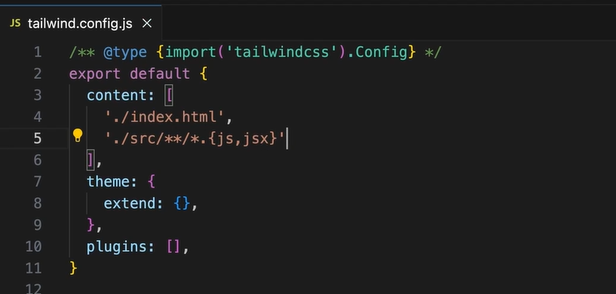

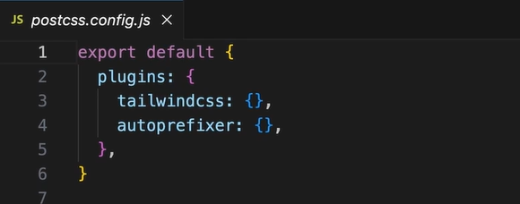

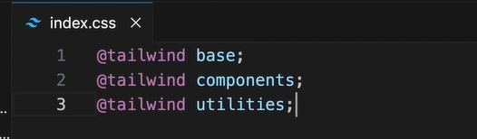

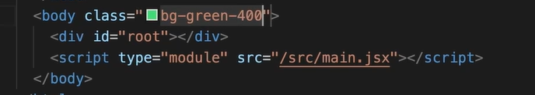

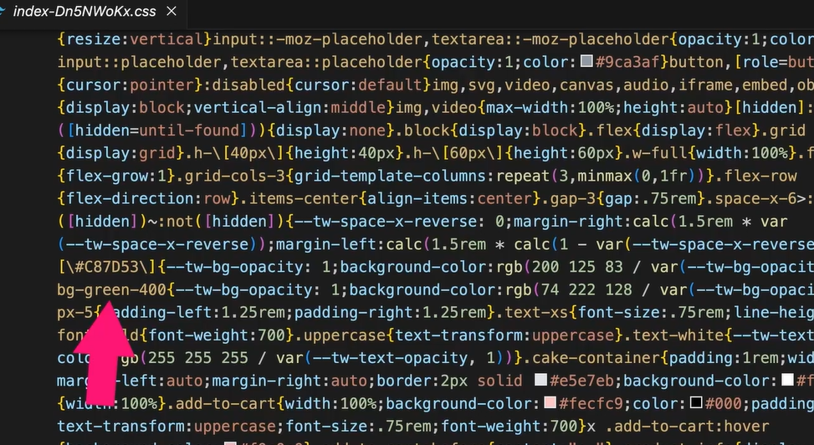

Styling React components with Tailwind CSS classes, we can create a variable and use that variable in the HTML to apply the class –

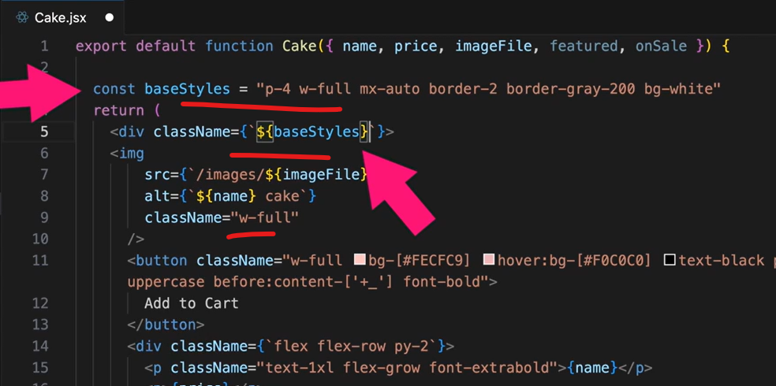

Applying dynamic styles –

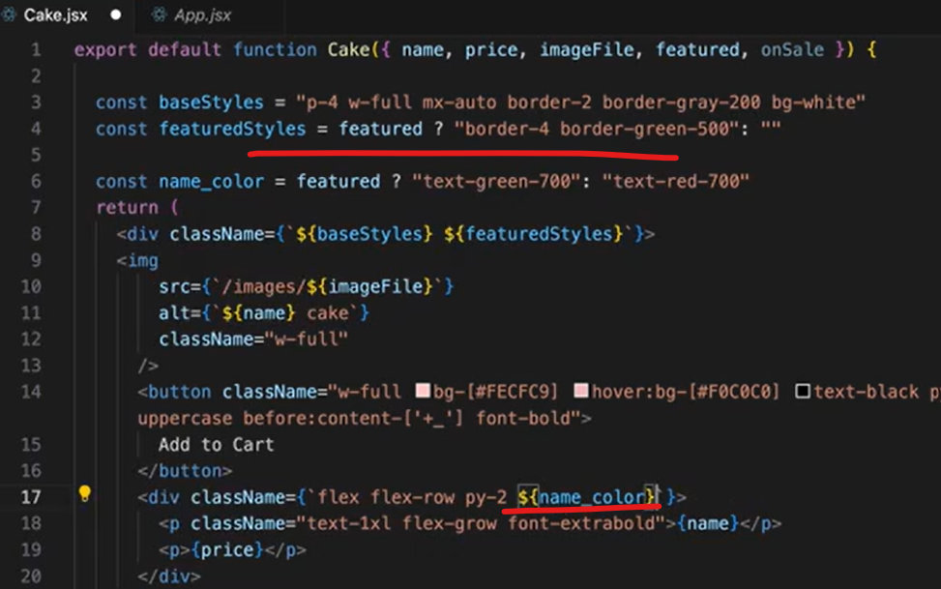

Using “safelist” attribute in the tasilwind.config.js file, these classes name would be always included in the build file, even if it doesn’t get appear up in the markup –

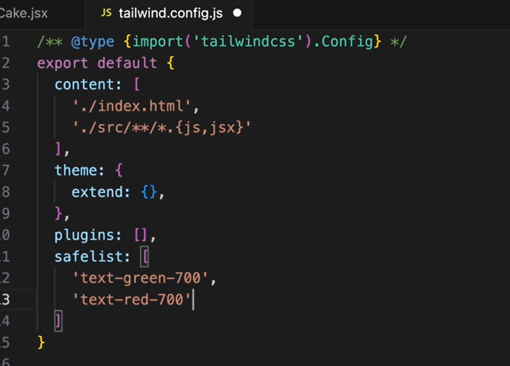

Tailwind merge – by using tailwind-merge to avoid CSS conflicts –

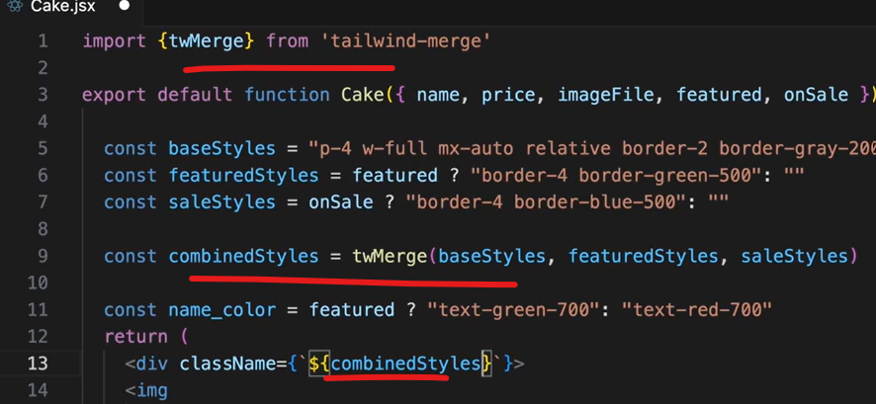

We can install a official tool called React Developer Tools to debug the React application – it will give the consolidate version how components are rendered and which props they receive.

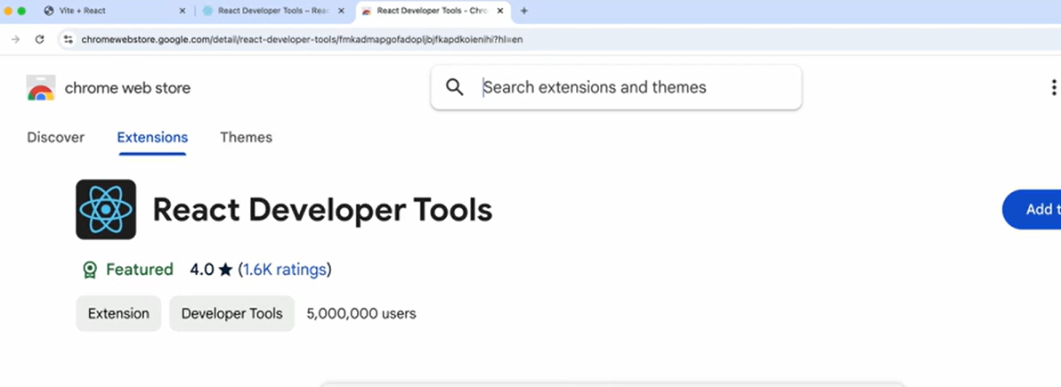

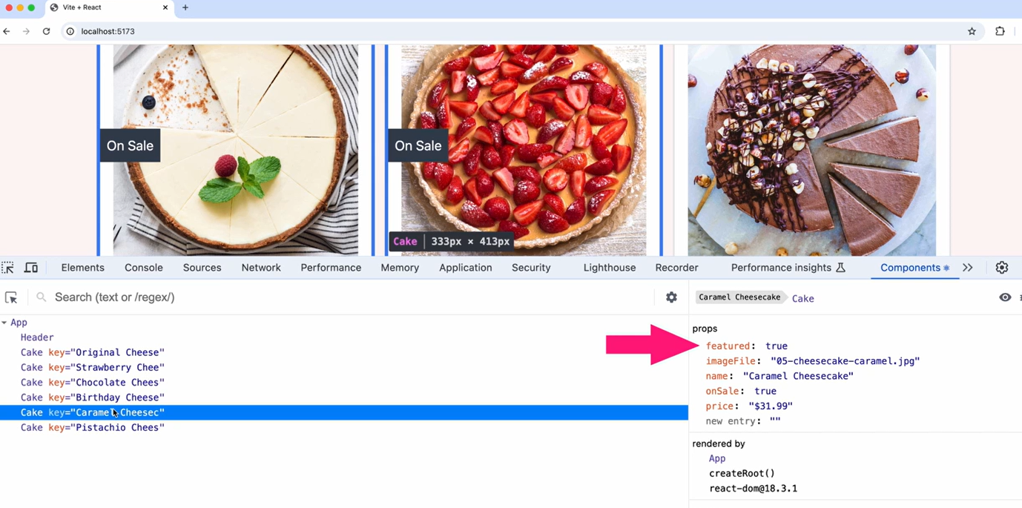

# Using Vite with React

Create React App (CRA) tool has been deprecated, now we should use Vite tool.

Unlike traditional tools, Vite doesn’t bundle our code during development, it lets the browser handle ES modules directly. So, no need for big bundling process in development, faster HMR for instant code updates, also it loads modules on-demand which increase developer experience.

The vite.config.js file –

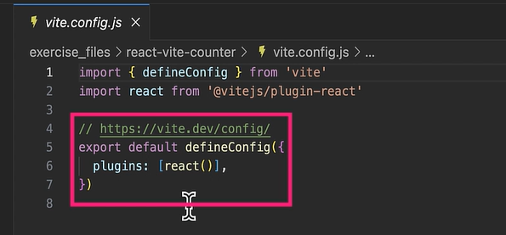

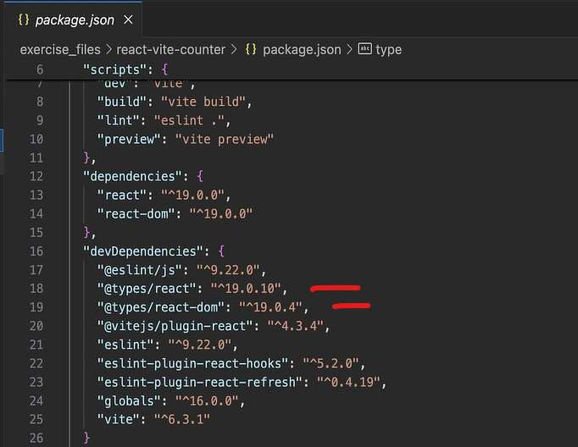

Configuring Vite for React – for testing we can use Vitest library –

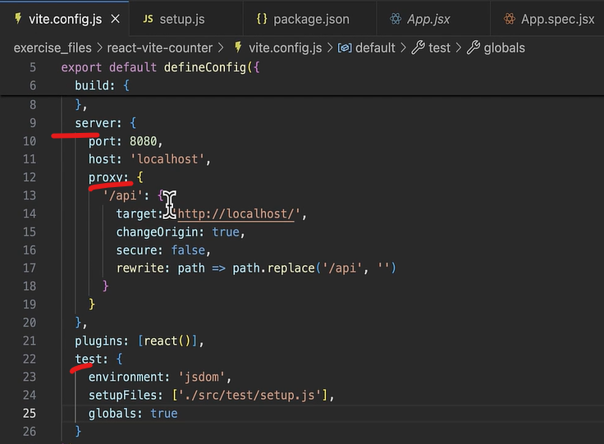

Using HMR in React – no need to refresh the browser on code changes, also the current component state is maintained.

Building for production – we can use React.lazy for code-splitting, we can also use Vite SSR for server side rendering.

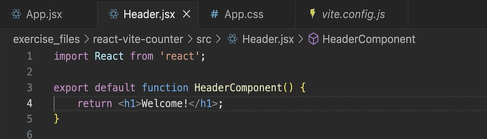

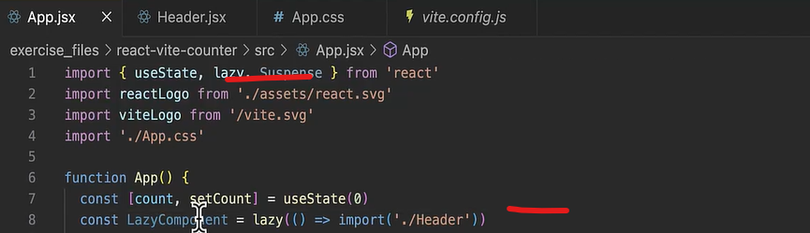

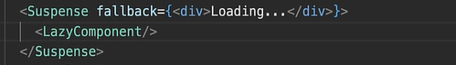

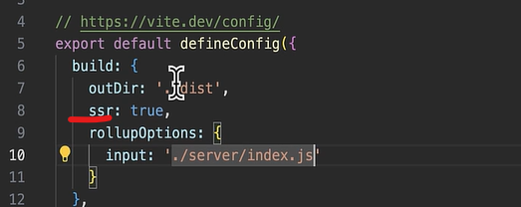

Optimizing and debugging builds tips – analyzing bundles regularly using rollup-plugin-visualizer, lazy load components, when possible, prefer named exports over default exports, marking pure functions for esbuild dead-code elimination.

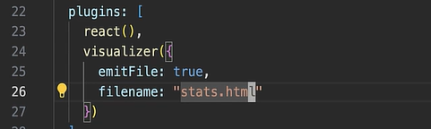

Stale updates in HMR with Fast Refresh – Fast refresh relies upon default exports this is how it knows which module to refresh. When we use named exports instead of default exports we can really throw off Fast Refresh.

Below is named export –

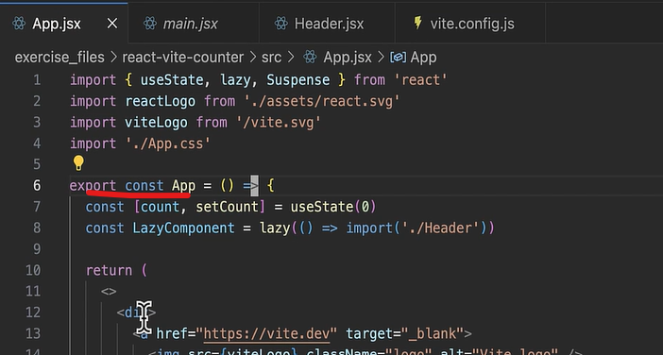

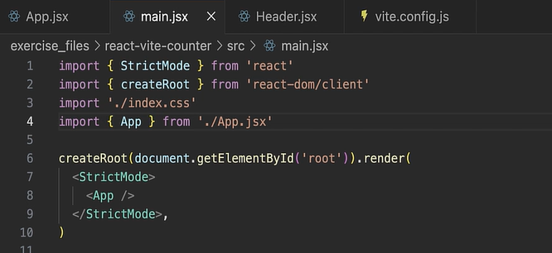

Below is default export –

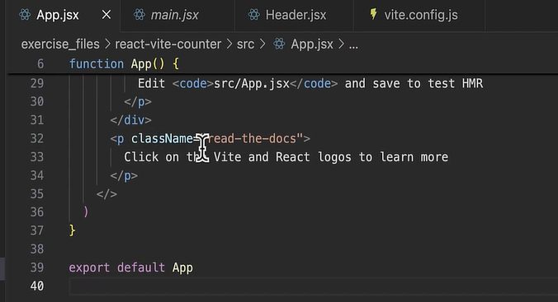

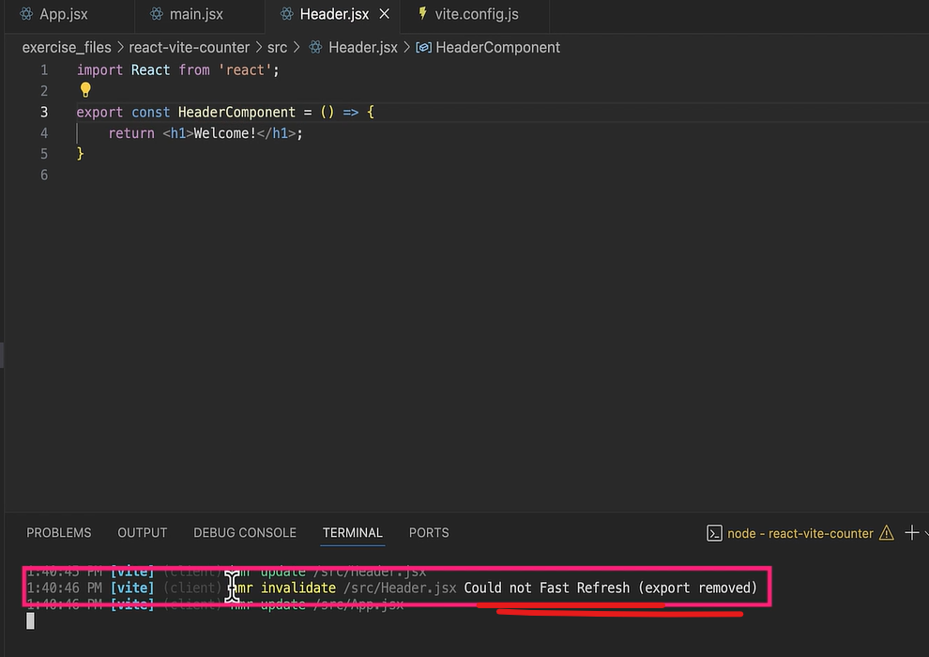

Enhancing workflow with Vite’s modern tooling – like using svgr() plugin to use svg as react component -

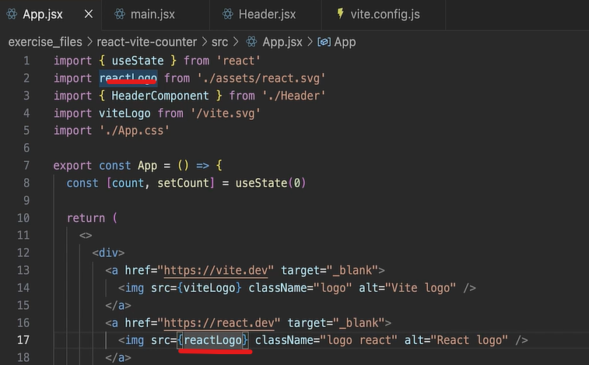

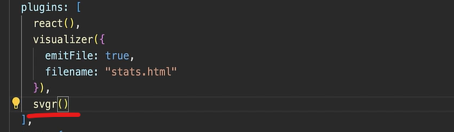

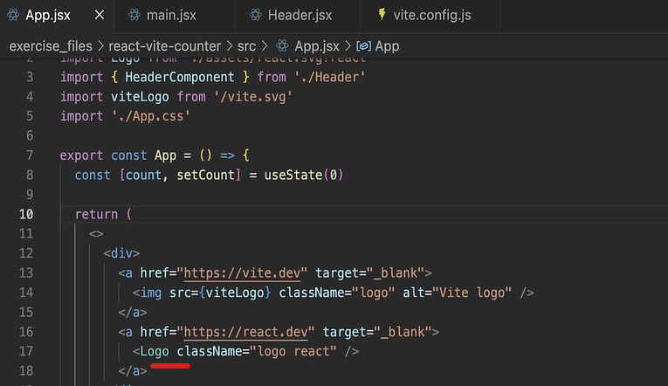

Managing environment variables – the variable should be pre-fixed by “vite” –

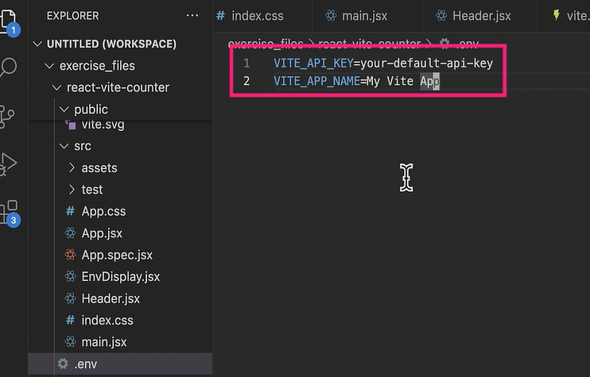

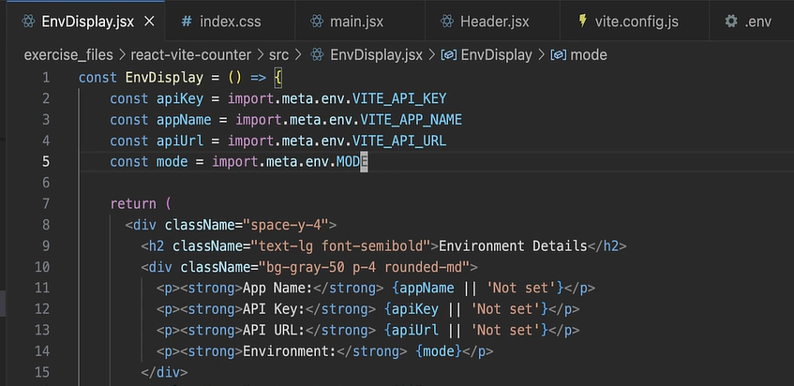

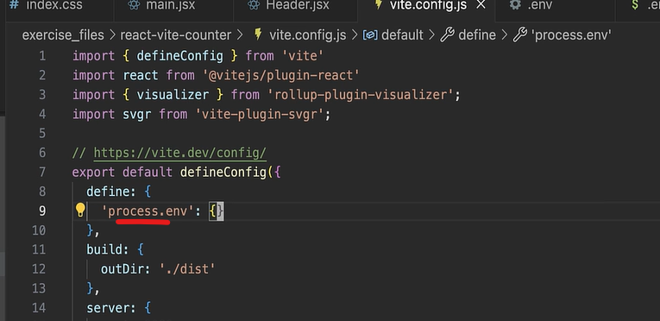

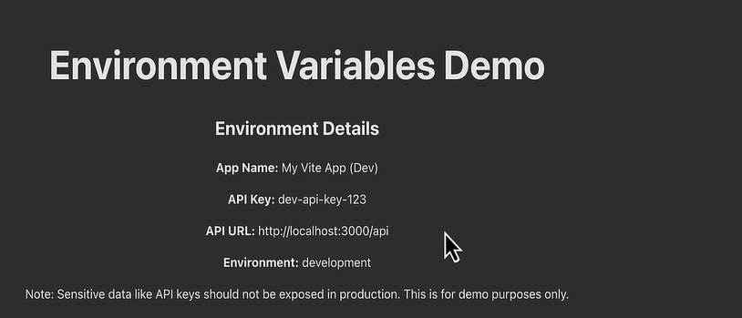

Using Vite’s styling tool for React –

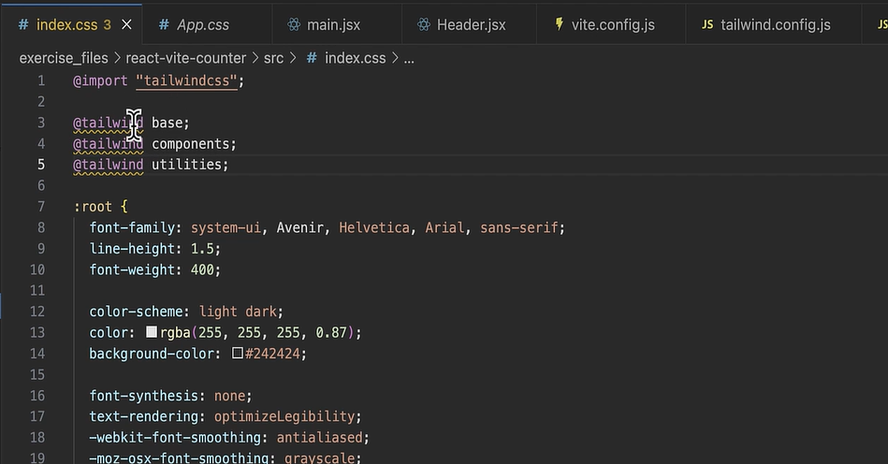

# Optimizing React Applications for Accessibility

Without semantic elements, it would be like walking through a maze blindfolded. While creating the custom components we need to ensure that they preserve the semantic meaning and provide a similar experience to native HTML elements.

Semantic HTML vs. React components –

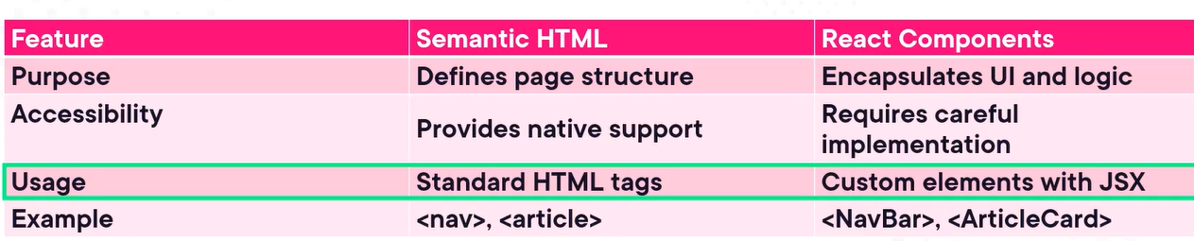

We should aria attributes while building custom components like a div styled to look like a button. It can help provide the missing accessibility information. ARIA should be used to enhance a11y, not replace semantic HTML.

Best practice – avoid overusing ARIA; start with semantic HTML first, also test how ARIA attributes affect screen reader output.

Tab index attribute – tab index as 0 makes elements focusable in the natural DOM order, tab index with -1 allows programmatic focus but excludes form tab order, avoid positive tab index values to prevent confusing navigation.

Focus managements – ensure focus is set to modals, overlays or new sections when they open, implement focus traps to keep users within modal dialogs until they close, maintain logical focus order when navigating dynamic content.

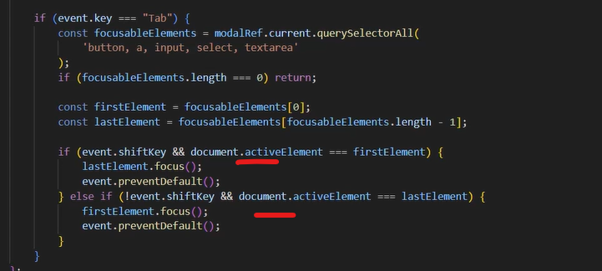

We can also use below generic method to move focus to the last element if shift + tab is used –

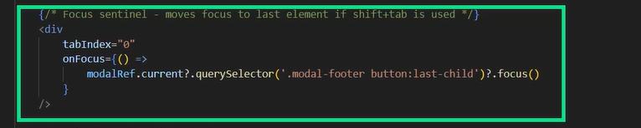

Theming in React – utilize CSS-in-JS or CSS variables to maintain consistent theming.

We can use library called @axe-core/react to test the application for a11y –

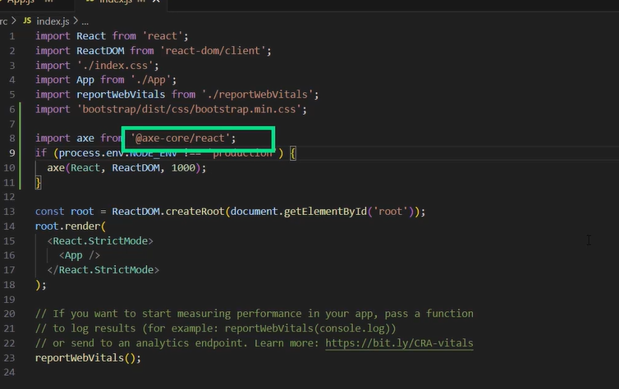

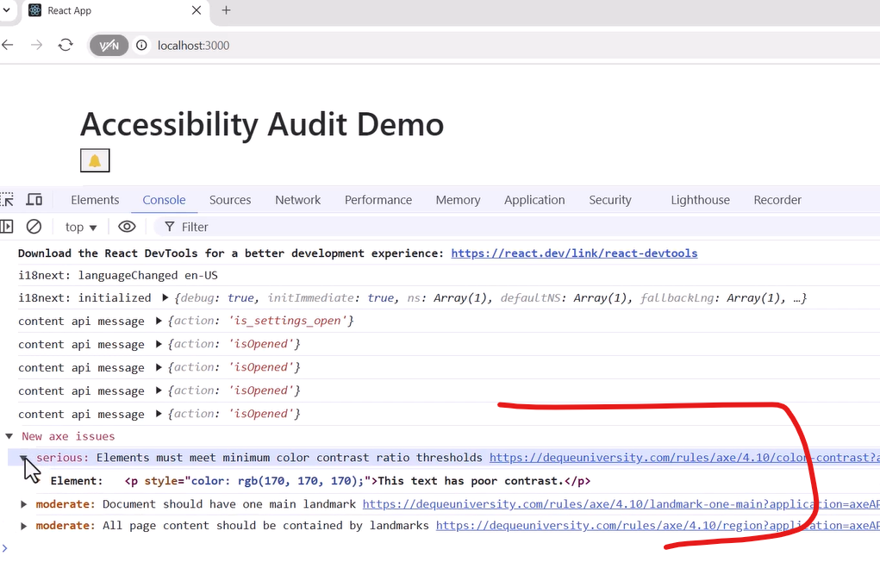

AI-powered React Applications: Creating Data

# Visualizations

# One Brick at a Time: Building with React

Creating a Lego bricks application –

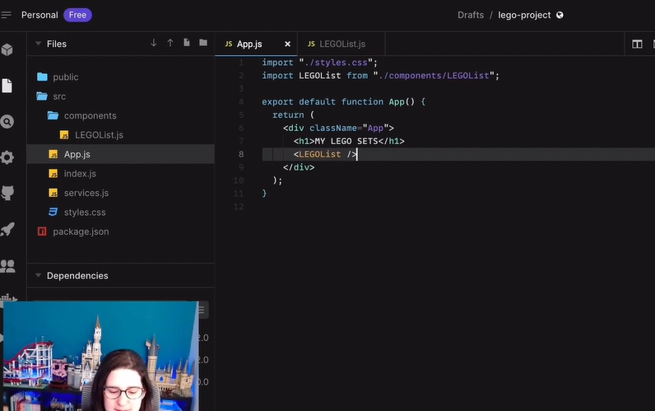

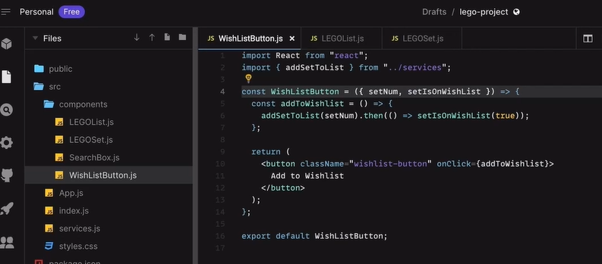

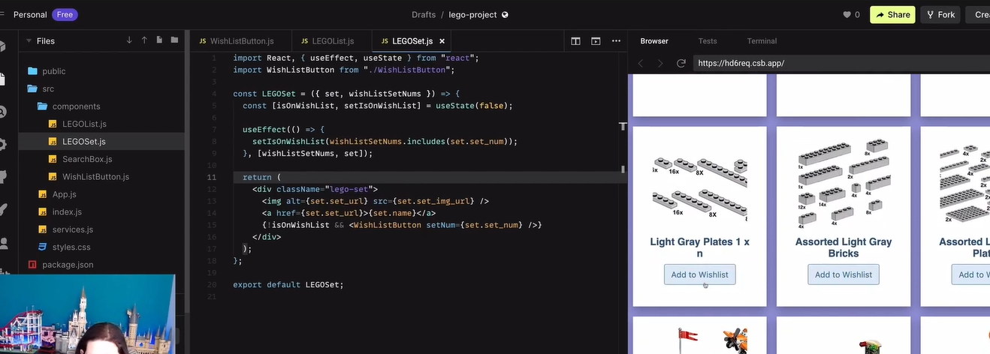

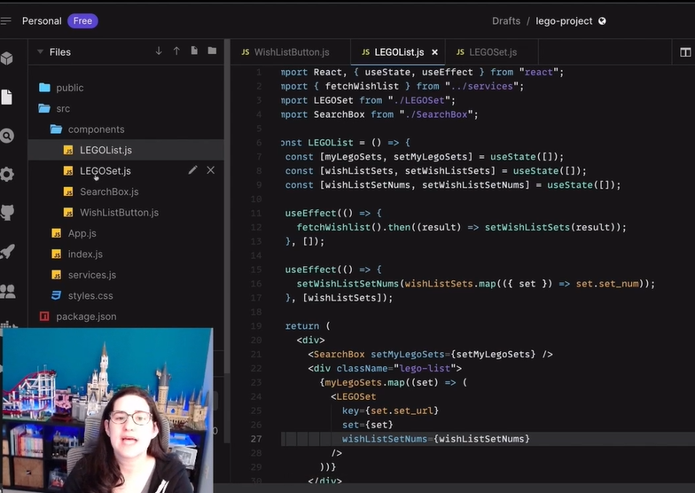

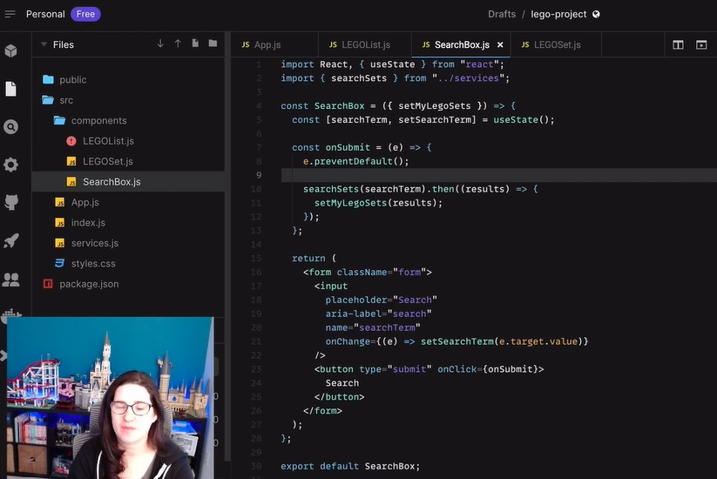

# React 18: First Look

React 18 is the most consequential release ever from the React team.

Concurrent features - Suspense – if UI is not ready yet, the fallback is rendered –

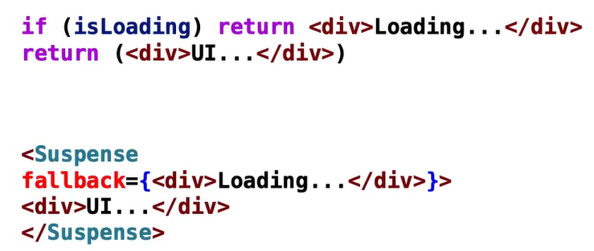

Concurrent features - Suspense list –

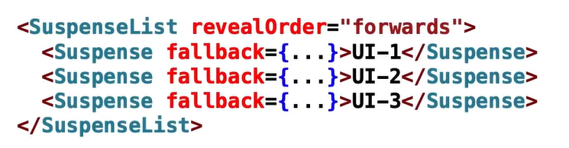

Concurrent features - Server components – allowing specific page components to be rendered from the server and downloaded to the browser.

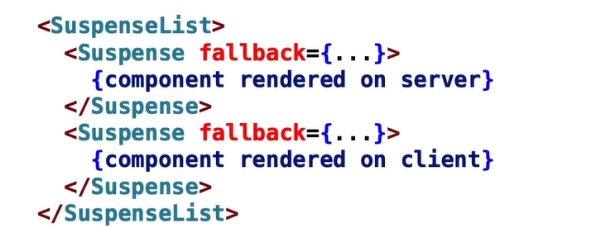

New react hooks – useTransition – allows hooking into the Suspense page lifecycle. useDeferredValue – allows for a better UI experience by showing a stale value instead of no value. useSyncExternalStore – used to hook into external data sources like a redux store, global variable or even DOM state changes, useId – used to create a unique id that can be generated for use on both the server and client (for server-side rendering and server components), batching – batching is when React groups multiple state updates into a single re-render instead of multiple re-renders.

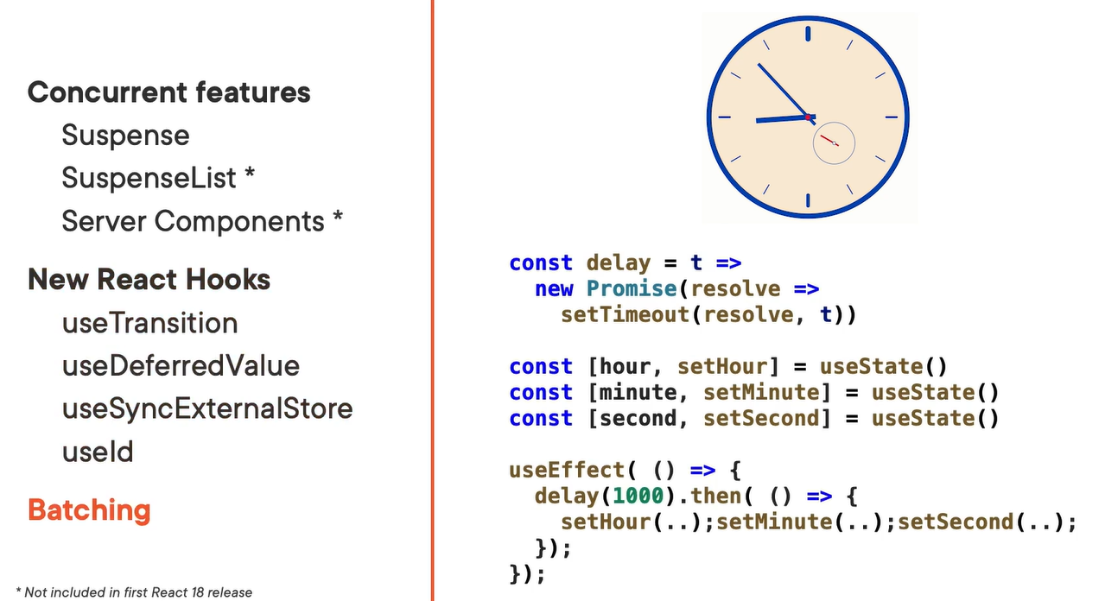

The motivation for Suspense in our React apps – just looking at the below code, we need to mentally keep track of the state in our head and then jump around to what’s executing when. When we get multiple components in our app voting states all over the place, it can cause a lot of problems in reasoning about the app and what’s really going on.

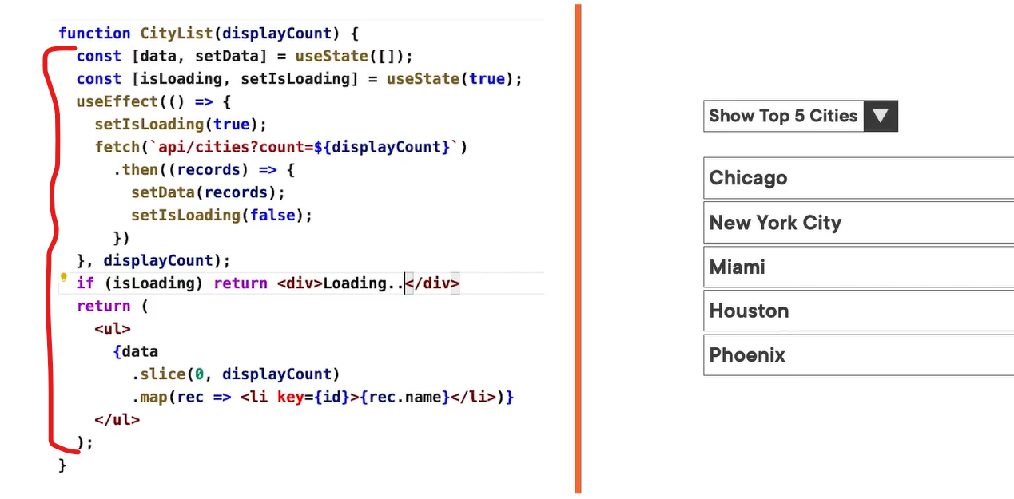

Simplifying our async component using third party libraries – the React hook built into them that surfaces much of the functionality we need, is what internally calls useEffect and handles all the async complexity on our behalf.



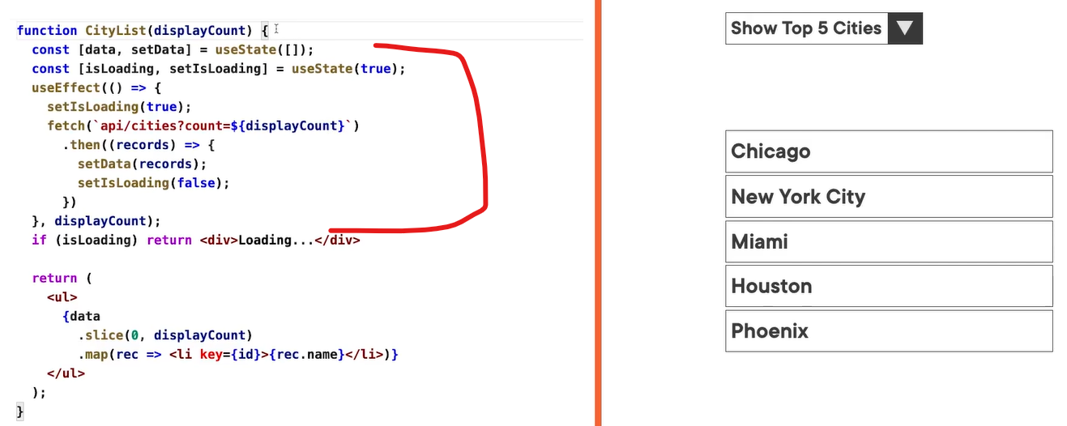

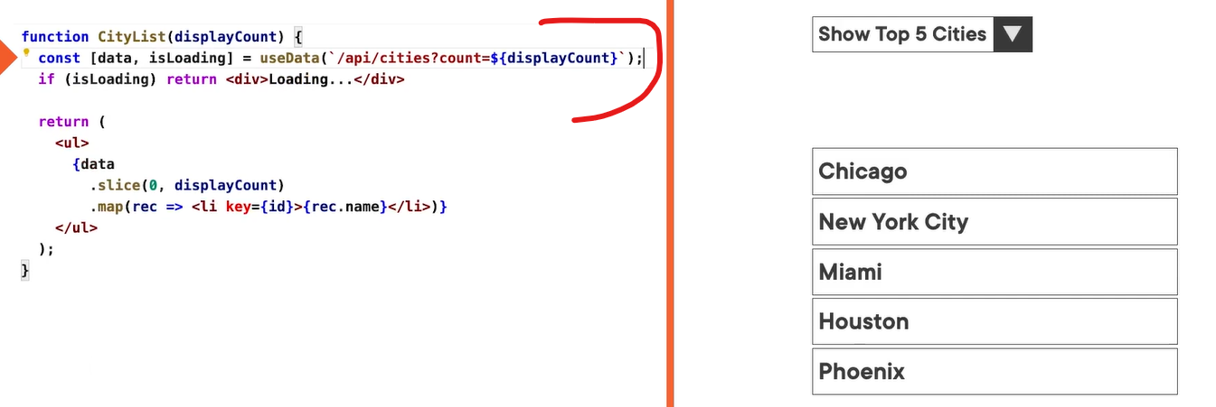

Refactor above code by using Suspense with declarative coding –

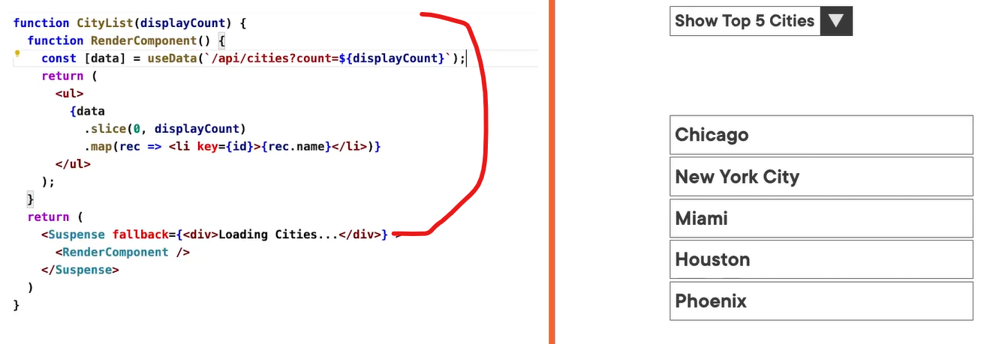

Nesting Suspense components and Fallback UIs –

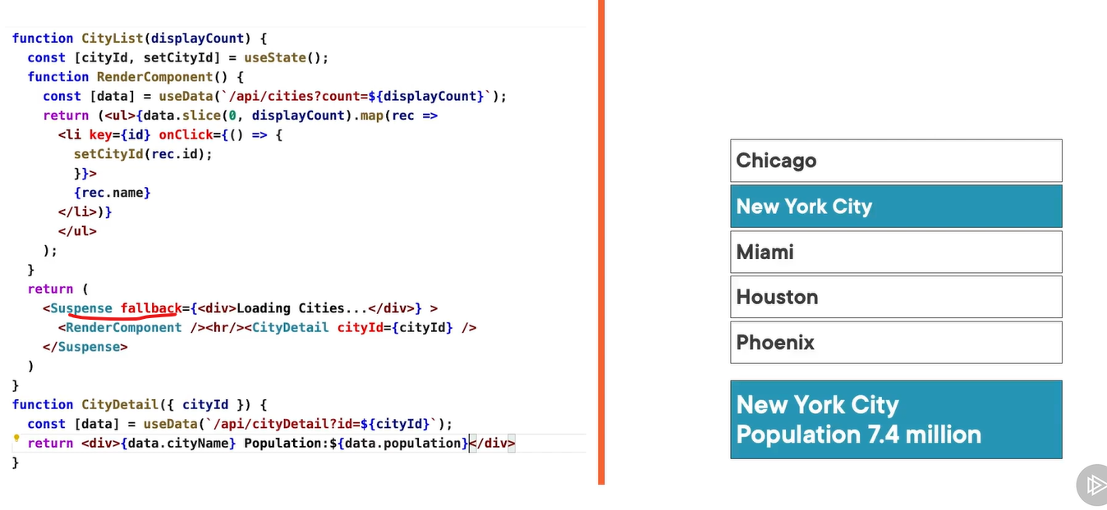

Hooking into the component lifecycle using Suspense – by using useTransition() hook we can get access to the rendering state of the particular component that we are in.

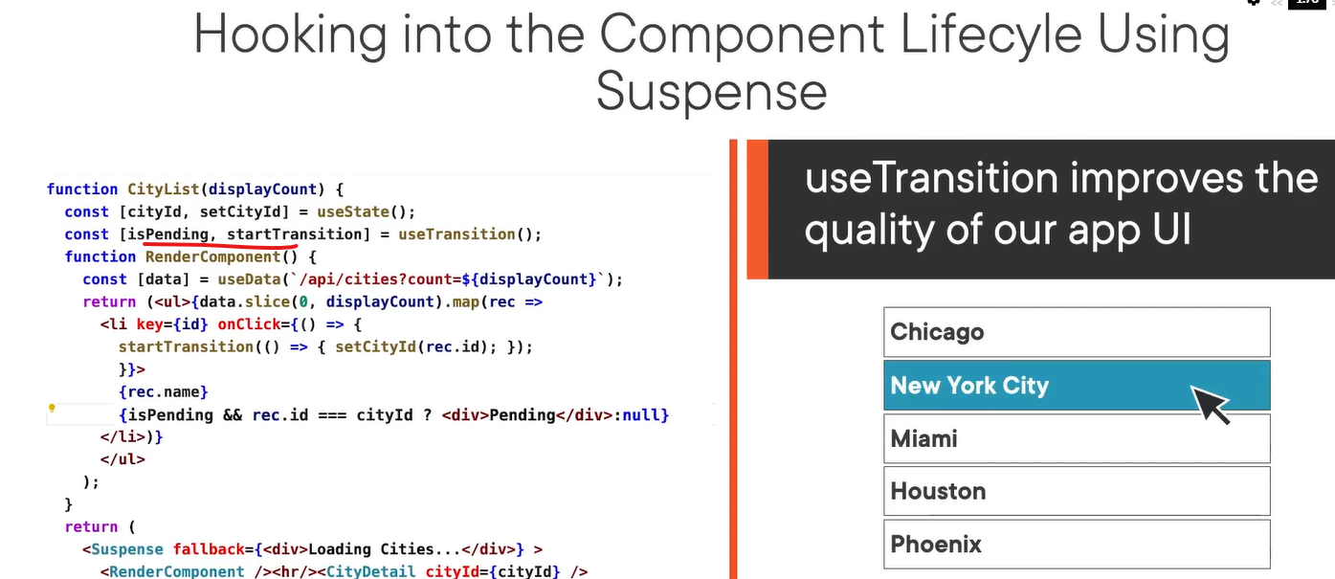

Generating a unique Id for HTML elements for server and client-side generated elements –

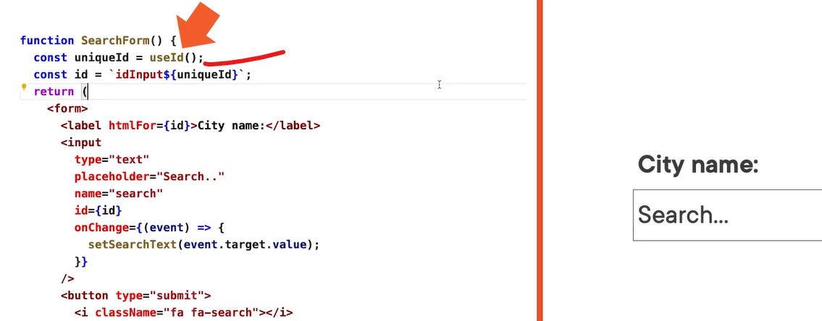

Batching support in React 18 - We can use useEffect() hook when we call multiple state setters upon returning from an async call, only one re-render of the component happens. In earlier React version three calls happen for seconds, minutes and hours but in new React 18 only one re-render will happen. In new version if we want three separate renders when we can wrap them into flushsync() –

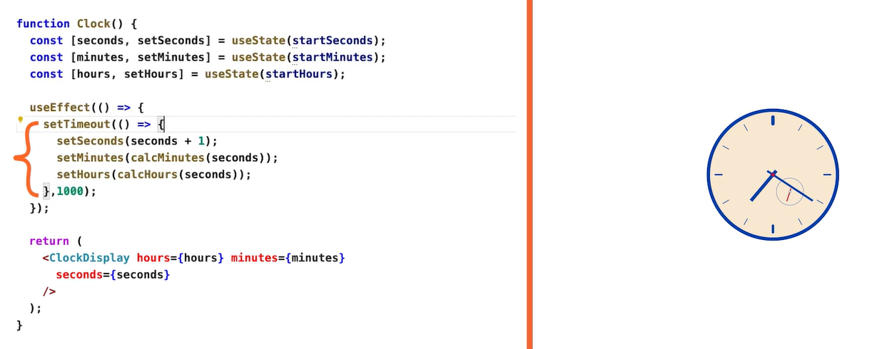

The main concurrent rendering feature in React 18 is Suspense.

React 18 changes – legacy rendering vs. new concurrent rendering – in legacy rendering, every rendering of the application the base call to our root element gets executed again and our entire component hierarchy, though likely all not re-rendered, does have to go through the render process again. In new concurrent rendering, we need to explicitly create an application root by calling the new method ReactDOM.createRoot while passing in the same container reference, this will impact on how React does hydration which is matching server generated code matching with client generated code.

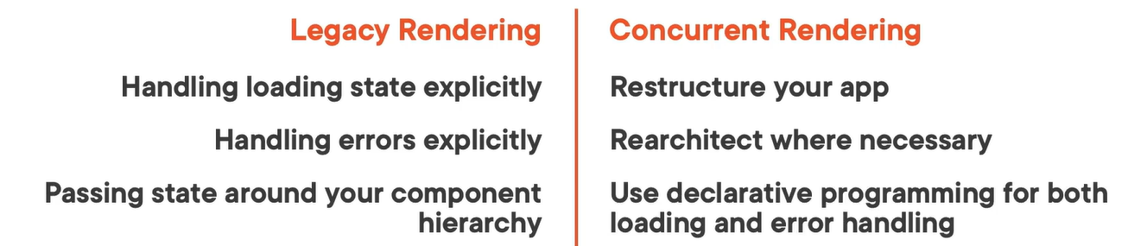

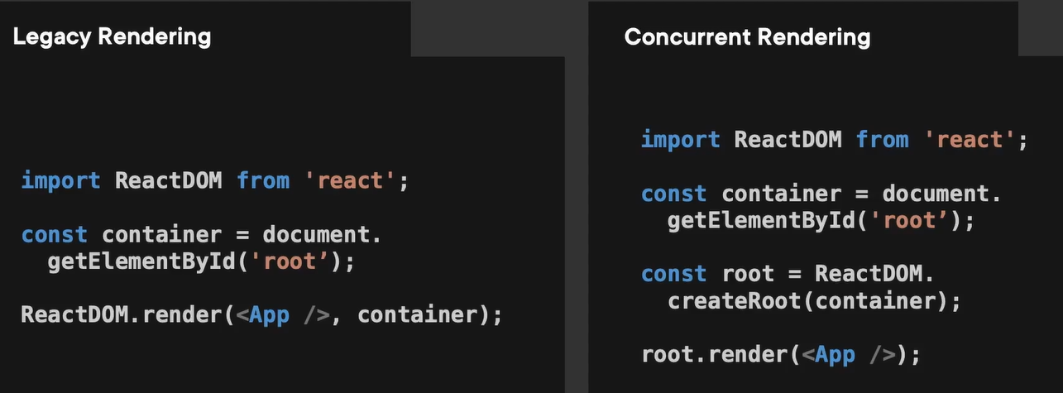

In current rendering mode both the click and the tick cause their own re-render cycles to happen completely independent of each other and will impact only those elements which will be impacted by them, instead of starting from the root component –

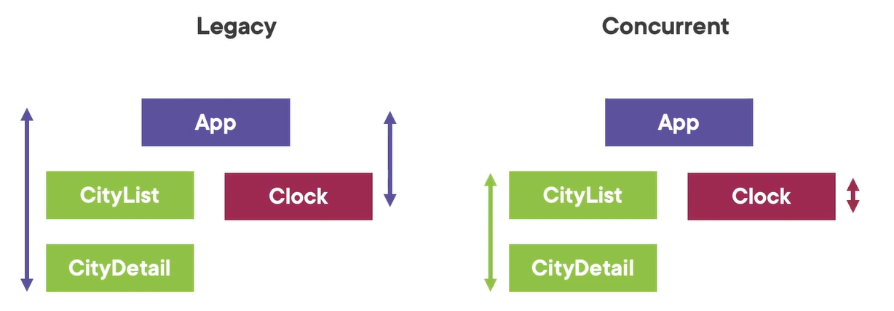

# Docker for Software Development: React Apps

A very simple docker file – two dots, first means the source directory at the current location where the docker file needs to be kept at root directory and second dot is destination location where our working directory is.

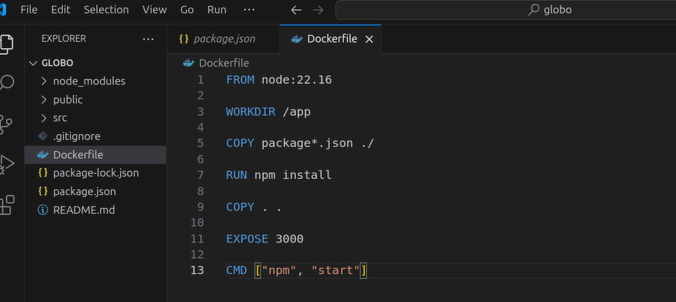

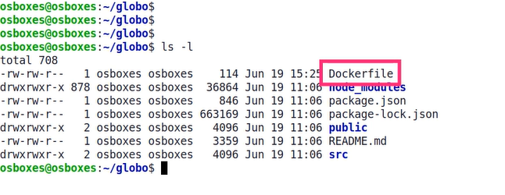

Creating a image command – docker build -t globo-dev .

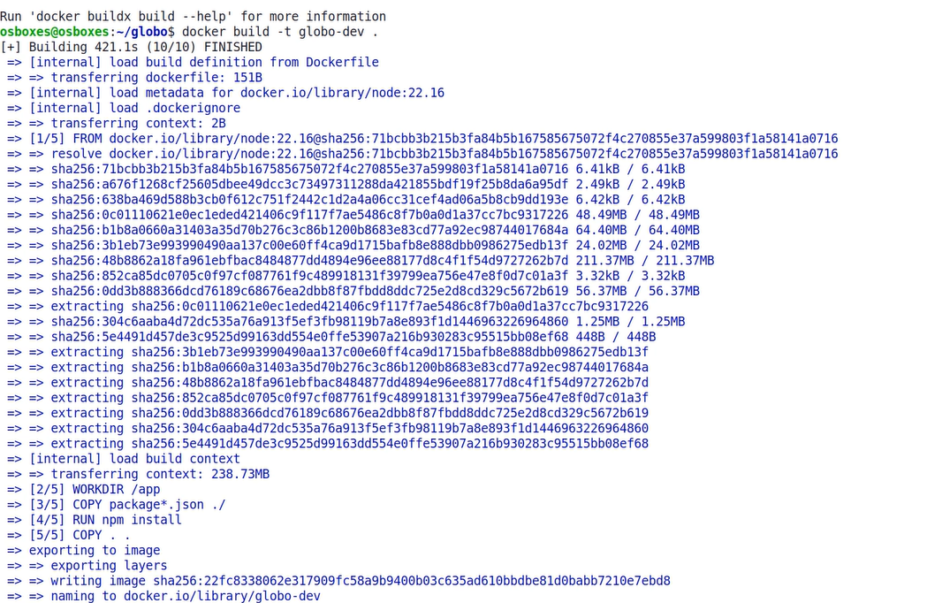

Another command to view all images – docker image ls

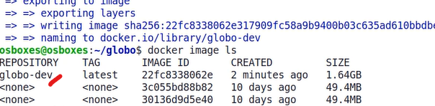

Running the image command – docker run -p 3000:3000 globo-dev

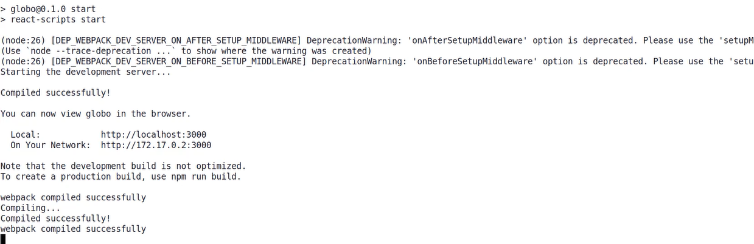

Checking the running containers – docker container ls



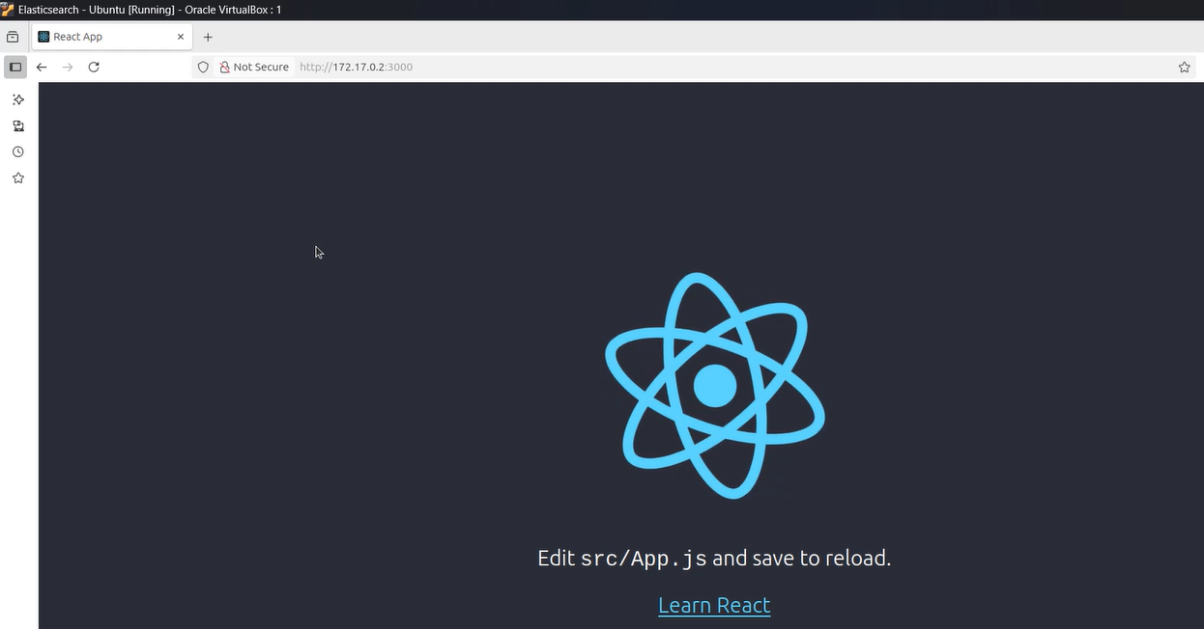

Hot reloading with volume – by adding an environment variable (CHOKIDAR_USEPOLLING) and mount our local code into the container using Docker volumes. It uses polling which uses more CPU than event-based file watching. It is strictly not recommended for production.

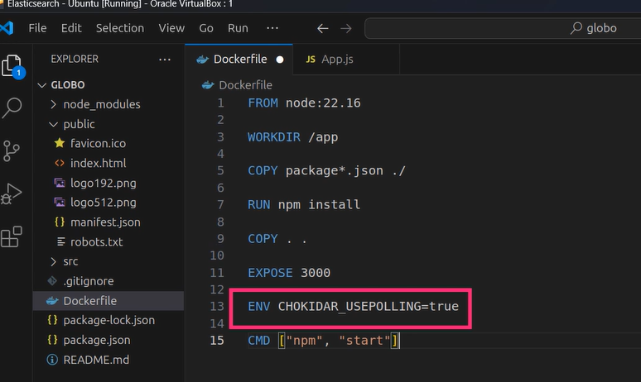

PWD refers to the current directory on the host machine –

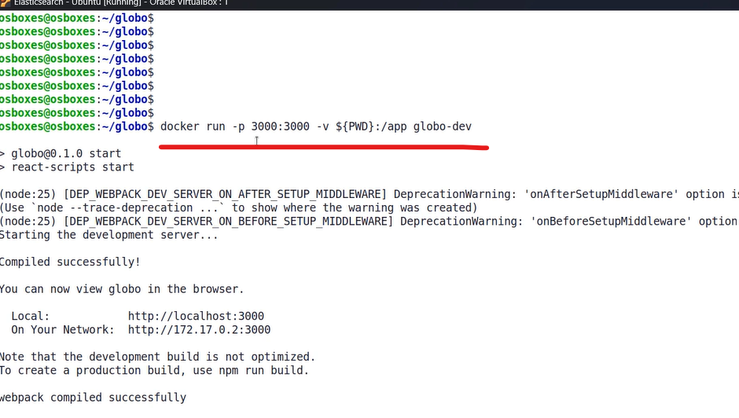

Developing with multi-stage Dockerfile – it maintains separate stages for building and serving the application. Generate smaller images sizes for production build stage, better security due to smaller attach surface. Cleaner separation of concern. Faster push and pull from registries.

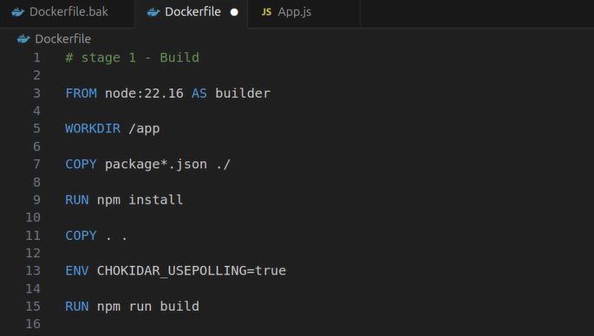

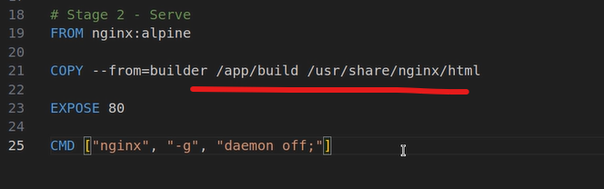

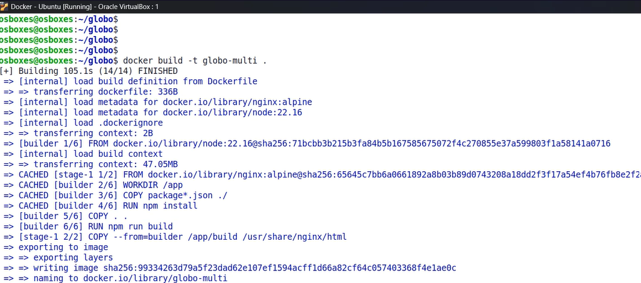

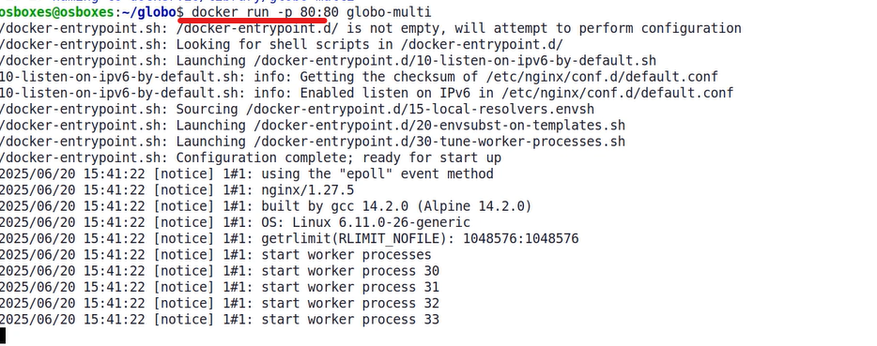

We can inspect how this Docker image is built layer by layer by running command “docker image history” –

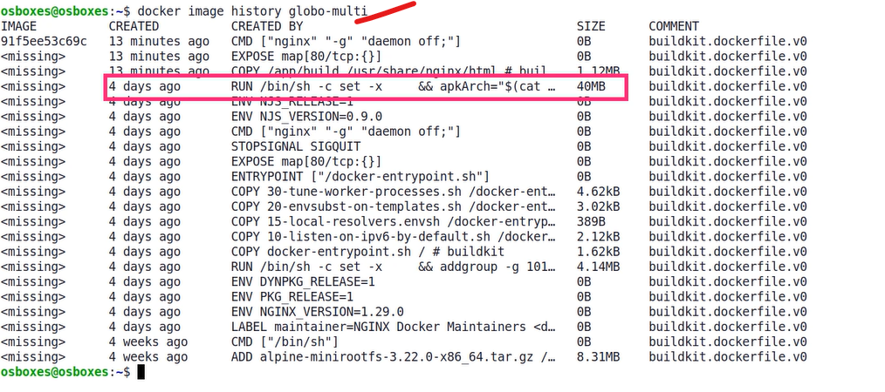

To see the truncated output as above highlighted square box is truncated, we can run command. It will be useful for understanding, auditing and optimizing the image –

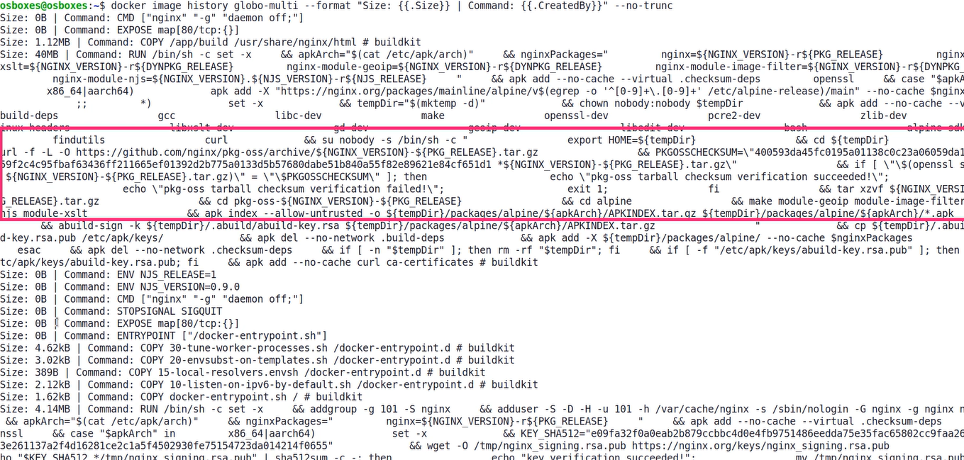

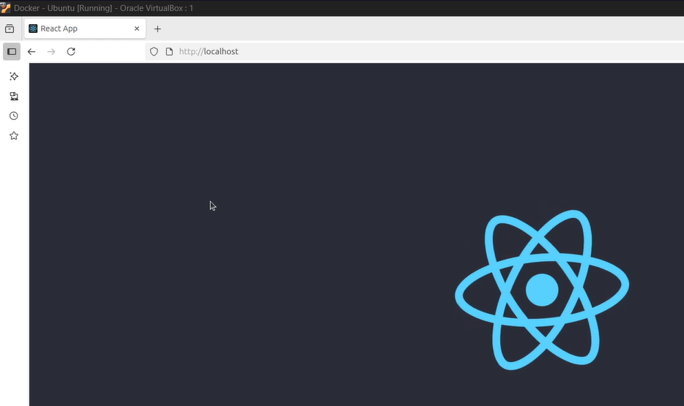

The size difference between the dev and prod image –

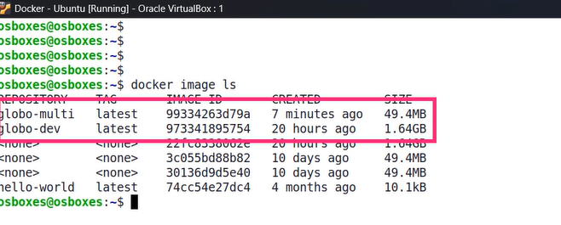

The .dockerignore file – it tells docker not to include the specified fiels and folders in the build context.

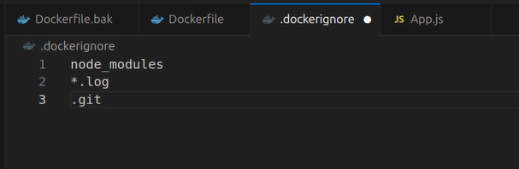

Enhancing the dockerfile to address unknown routes in the nginx conf file, below will go to index.html page when no matching route is found instead of showing the 404 error –

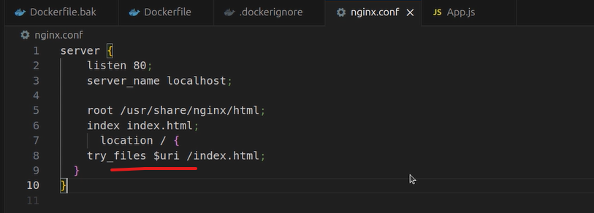

As we now have a custom nginx.conf file, we need replace the default nginx.conf file with it –

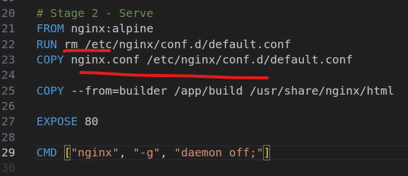

By below we can create the environment variable in the docker file and read it in the react app, react will only pick those variables which starts with “REACT_” –

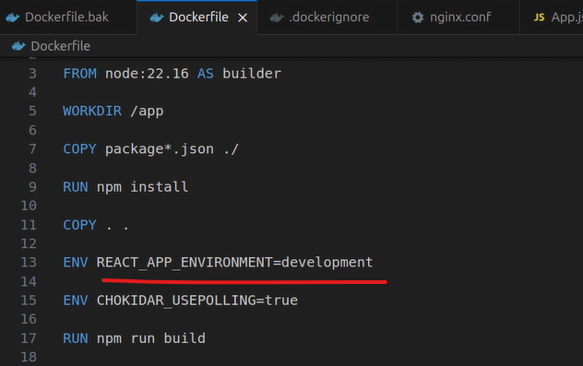

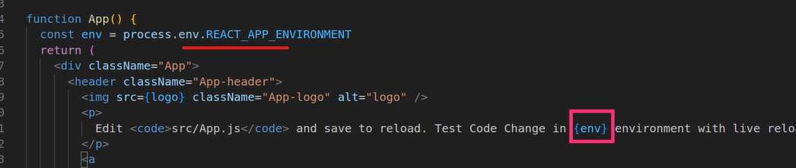

Best practice – instead of finding and running the docker container with its ID, we should name our container and run it by giving the readable name and run it in the detach mode.

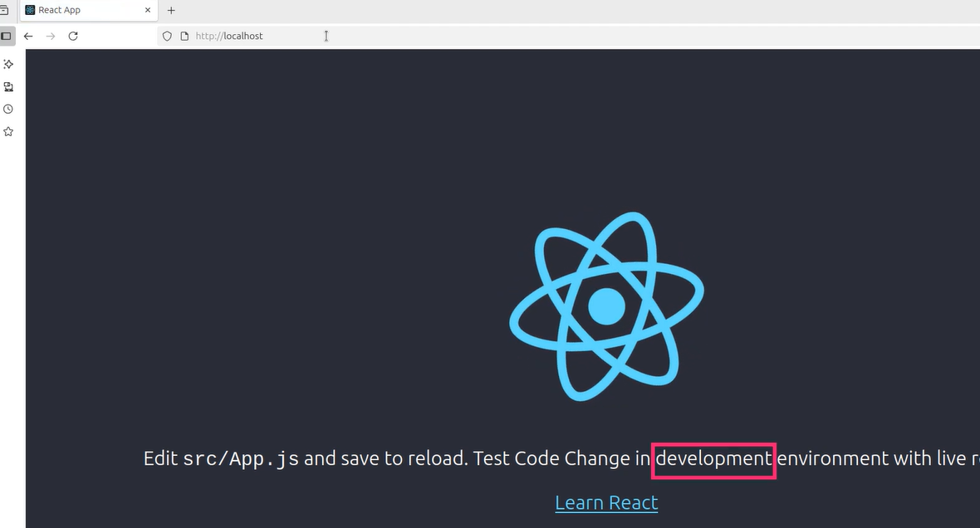

Other best practices –

